“50 for 50”
Riding It All: Skis, Boards, and Entertaining Objects
It all started as a birthday stunt. My grandmother Mary Murphy rode her Sky Ski across open ocean to Catalina Island at age 79. For the next 8 years she rode there and back - 52 miles dodging sharks and dolphins - to celebrate each birthday in her 80s. When it came time for my 40th, I decided to do a ski challenge too, just like grandma. So I set out to ride 40 miles on 40 different things and do 400 tricks, all in one day. It was called the MasterCraft 40-40-400.
I ran out of regular stuff at 27, so it was time to get creative with things like a snowboard, piece of wood, and a picnic table. Since then riding odd objects has become something of a specialty, and I love to increase the entertainment value by adding a fun costume when possible.
“Will you ride 50 things for your 50th?” has been a recurring question, and the answer is a resounding yes! I’ve had nearly 10 years to think and plan, so there will be several changes to maximize performance, promotions, and overall show value.
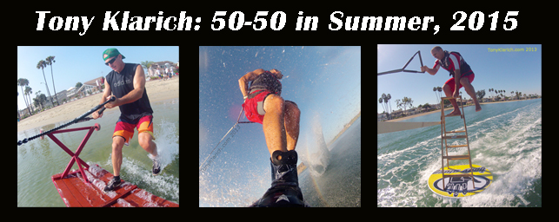
- 50 different rides, all in one day
- Long Beach Marine Stadium, SoCal (renting for the day)
- 100% charity event for Boys Town California (minimum $4K committed)
- Maximum media (day of): press, TV, photos, video, & more
Promos leading up to event.
- http://TonyKlarich.com
- Documenting the journey on Instagram @waterskierslife (1,640 followers since May, 2013 and climbing)
- YouTube “TonysTipsAndTricks” (as of Oct, 2013) 1,765 subscribers, 1.4 million views. I continue to produce videos documenting the journey.
- Facebook: 1000+ followers / friends
- Press Releases to Media Outlets
I am partnering with innovative companies who can help me promote this event. Already on board: Body Glove and California Skier. With a lead-time of more than one year I’m actively looking for more!
Post Event - Promotional Value for Decades to Come
Once the initial run of event pictures is done, I will be releasing event photos for free using a creative commons license (this ensures they will stay in circulation for decades to come)
I will be producing a series of event videos for YouTube…

