ADVENTURES IN WATER SKIING: THE RIDE OF MY LIFE
PART 1, HOT DOGGING

by
Tony Klarich
http://tonyklarich.com

Edition 1.1; April, 2012

Some Rights Reserved. The TEXT ONLY of this publication MAY be used or reproduced in any manner whatsoever without written permission. All use must be accompanied with the attribution: “From Adventures in Water Skiing: Part 4, Hydrofoiling. Used with permission by http://tonyklarich.com”. TEXT ONLY is licensed under creative commons agreement (CC BY 3.0). The images (photos) MAY NOT be used, uploaded, reposted, or reproduced in any manner whatsoever without written permission.

SERIES TITLES
>Adventures in Water Skiing: Part 1, Hot Dogging
Download interactive word document for FREE at http://tonyklarich.com
>Adventures in Water Skiing: Part 2, Kneeboarding
Download audiobook for free at tonyklarich.com
Listen to individual chapters on YouTube: KNEEBOARDING Chapters Playlist
>Adventures in Water Skiing: Part 4, Hydrofoiling
Download interactive word document for FREE at http://tonyklarich.com

READ WHAT OTHERS ARE SAYING ABOUT THIS E-BOOK
“Tony Klarich is a water skiing encyclopedia. His first hand experience with so many innovations and progressions in the sport make his book a “must read” for water skiing enthusiasts.”
-Terry Dorner; Vice President, World Sports & Marketing, a division of Bonnier Corporation.

“No one is better suited to tell the tale of the amazing changes in water skiing at the end of the 20th century. I especially enjoyed Tony’s review of the early days of HO Sports when we were Team Riders. Words, pictures, and even links to our old videos brought the story to life. For anyone interested in the history of skiing, “Adventures” is any easy read that was hard to put down!”
-Deena Brush; 10-time World Record Holder in jump and slalom, 38 consecutive Jump Championships, Water Ski Hall of Fame member.

“Tony Klarich has done it again. As watersports' eternal innovator, "The King" has launched a visual history of hot dog water skiing as colorful as 80s neoprene, from underground sessions with his uncle Mike "Pinto" Murphy to photo shoots on the sport's biggest stage. Where others of his generation may have won more world titles or bigger money, Tony's the guy with the longest legacy, whose signature tricks are emulated by nearly everyone who gets behind the boat.”
- Rob May; Editor, WaterSki Magazine 1990-1997.

Tony Klarich did an awesome job taking me back to the days when water skiing developed into a media sensation, and hot dogging was an important part of that exciting period. I loved the old magazine photos and video links that illustrated his adventures. In a matter of moments I was watching classic footage of Tony’s tricks on a slalom ski, Brett Wing’s highlight reel, and much more…all right on my phone. So very cool!”
-Peter Nelson; Producer / Director Waterworld Stunt Show, Universal Studios; Former Ski Show Director, Sea World of San Diego. http://amphibianstunts.com

“Much of what you see done on the water today is a result of the out of box thinking of Tony Klarich and his uncle Mike Murphy. Like the boys of "Dog Town" Tony and Mike were unforgettable entertainers and innovators on the water. They helped re-invent the sport, showing the skiing world new ways to ride. I loved being a part of watching skiing explode and change, and at the front of that explosion: Tony Klarich and his uncle Mike. If you own a boat, have strapped on a wakeboard, or ever been on the water, you must experience this innovative book! Adventures in Water Skiing defines the essence of extreme water spots as Tony Hawk and Travis Pastrana defined the X-games.”
- Dr. Terry Weyman, Medical Director - Professional Water Ski Tour, 1989-1996. http://gotcsi.com

“Mainstream sports like professional football, baseball, and basketball are some of the most excessively scrutinized, dissected, and over-documented preoccupations of the American sports scene. Unfortunately, at the opposite end of the spectrum, athletic pursuits generating only meager monetary returns seldom warrant serious attempts of preservation for posterity. That's what makes Adventures in Water Skiing so special. It is a genuine from-the-heart and the-head account of a multi-decade journey of hot-dog water skiing as seen through the eyes of someone who was there and lived the life. Nothing's contrived and egos have been parked back at the dock. A compelling saga told with amazing detail and honesty.”
-Bob Brown, Past Executive Editor, Powerboat Magazine and Editor/Publisher, Classic Custom Boats Magazine. Communications Director, Southern California Marine Association. http://www.mediadirection1.com/

“The 1980s and 1990s were exciting times in water skiing, and Tony and I go back many years to those glory days. It's great to see him document that special period in water skiing. Now the history of our sport can be remembered and shared throughout the world!"
-Brett Wing, 3-time World Overall Barefoot Champion, world-renowned showman and Hall of Fame inductee. http://brettwingwatersports.com/
* * * * *

TABLE OF CONTENTS
About the Author
Preface - Note to the Reader
Acknowledgments
Disclaimer
Prologue
A Turning Point - The Slalom Ski Front Flip
Water, Baby
Learning to Ski
Mike Murphy and the History of Hot Dogging
Striving to Win
Ch-Ch-Ch-Ch-Changes
On the Mighty Colorado River
Coming of Age
Be Like Mike (and a Few Others)
Dog Days of Summer, 1982
ISKI4HO
Reality Check
63-Inches of Vertical Air
Hotdogger’s Hangout
Out to Pasture with a Stable of Tricks
Afterward
Photo and Video Credits

ABOUT THE AUTHOR
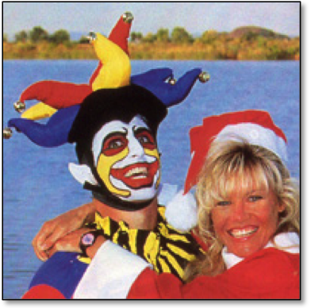
Klarich as “The Joker” with his wife Shonna.

Tony Klarich has been a water skiing innovator for over 30 years. He has invented more than 100 tricks on a slalom ski, sit down hydrofoil, kneeboard, and wakeboard. In competition Klarich has garnered ten National and World Titles.
“The guy who can ski on anything” took to the water for his 40th birthday, completing 40 miles on 41 different devices while performing 275 different tricks. Guinness World Records declined to recognize the one-day feat saying it was, “a little too specialized for a body of reference as general as ours”. Undaunted, Klarich plans to break his own record on his 50th birthday with 50 different items in one day, with one of the items being the Guinness book itself!
As a 25-year member of the Screen Actors Guild he has appeared in numerous videos, TV commercials, and movies. He has also written over 300 feature and instructional articles for magazines worldwide.
Klarich’s biggest skiing influence is his uncle Mike Murphy; legendary hot dogger and co-inventor of the kneeboard and sit down hydrofoil.
Klarich is also a licensed doctor of chiropractic in California and Idaho.
He is married with one son.

Producer / Director
Producer: Flight Worlds (hydrofoiling World Championships, 1996-2003)
Director: Hyperlite Wakeboards Amateur Tour (1996-97). Organized over 200 events, created “Tournament in a Box” template for grassroots wakeboard tournaments.
Video Director/Videographer/Script: Hyperlite Boarding School 1 & 2, Hyperlite Twin Tail Ride Guide, 1998 Flight Worlds, Flight Worlds 2000.

Writer / Publisher
More than 300 articles published worldwide. Mostly water skiing instructional and feature stories in Water Ski Magazine, Wakeboarding Magazine, Trailer Boats, Flight World & numerous international publications.
Publisher: FLIGHT WORLD HYDROFOILING (1997-2001).
Author: Hot Dog Water Skiing and Adventures in Water Skiing.

Numerous Video & TV Appearances Including: Nabisco Better Cheddar, Stanley Tools, Michelob Dry, Juicyfruit Gum, Ford Trucks, Selsun Blue, TV Host of “On the Water” & many more!

CONNECT WITH TONY KLARICH:


ADVENTURES IN WATER SKIING ON FACEBOOK


ALL ORIGINAL CONTENT ON YOUTUBE

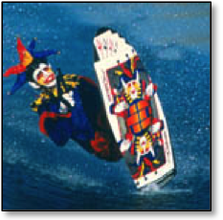
CLASSIC SKI FOOTAGE, LINKS FROM THIS BOOK, AND MORE ON YOUTUBE

YouTube Playlists:
Wet & Wild - My Best Skiing
Wacky Water Skiing - Rides on a Hydrofoil Bicycle, Picnic Table & More.
How to Hot Dog Slalom Ski

PREFACE - NOTE TO THE READER
Someone asked me why anyone would be interested in reading a book about me. After getting over some hurt feelings, and thinking hard about it for a couple of days, I came up with an answer that satisfied them---and me too!
My “glory days” in water skiing corresponded with the explosion of watersports in the 1980s and 1990s, including the creation and rise of hot dogging, kneeboarding, wakeboarding, and hydrofoiling. I had a front row seat to the exciting development of each new sport as a pioneer and top competitor. I’ve already written hundreds of articles, and have a collection of thousands of photos and videos, so I was in a perfect position to document these sports!
This book is autobiographical, especially Part 1: Hot Dogging. I sparingly used key childhood events off the water to help explain why I ended up being a skier who was always motivated to seek out the next challenge, do things never done in water skiing, and share my success to the world through performances.
You will find that my personal story is also the story of these sports, how they developed, and how they relate to each other in the bigger picture (my life in kneeboarding, wakeboarding, and hydrofoiling is already in the works). The longer format of an e-book allowed me to dig deeper into the history than ever before. We are far enough away from the rise of these sports to get some perspective, but not so far to have lost touch with the innovative personalities directly responsible for creating these new ways to ride.
The recent media developments have also allowed me to present Adventures in Water Skiing in a whole new way. In additions to the scores of photos, there are also dozens of links to even more related materials including magazine articles, timely websites, and classic videos.
On a final note, it has been very important to me that this body of work can stand as a respected historical record for water skiing. I have worked extremely hard to get the facts straight, and tell each part of the story with as much research and insight as possible. I hope that future generations who read these words can find a source of credibility, insight, and of course, entertainment.

ACKNOWLEDGEMENTS
My uncle, Mike Murphy: he led the way and I followed.
My grandmother, Mary Murphy: keeper of the family images and ageless inspiration on the water.
Herb O’Brien embraced my unique abilities and took me for a wild ride.
Carole Lowe for her invaluable research assistance at the Water Ski Hall of Fame.
“Huge Al” Van: proofreader extraordinaire and always a “Huge” help.
Terry Dorner: champion of hot dogging and critical image acquisitions.
Art Brewer: my first pro photographer, and benefactor of priceless photos.
Tom King: the guru of Water Ski Magazine photography.
Mom, Dad, and my wife Shonna: endless support to follow the dream.
To the unsung heroes and helpers, I thank you all!
* * *

PHOTOS BY:
Tom King
Art Brewer
Rick Doyle
Mary Murphy
The Water Skier
Powerboat Magazine
Spray Magazine
Water Ski Magazine
Terrence Dorner
Jungle
Harvey McLeod
Marc Spencer
Doug Dukane
K. Waddell
Jim Wooodworth
Mary Klarich
Victor Davila
American Water Ski Educational Foundation (AWSEF)
Tim Trella
Wayne Wilms
Jeff Hyman
A complete list of individual photos by specific photographers and publications (with dates) can be found at the end of the book.

DISCLAIMER
I have and will continue to make every effort to create a story that reflects how water skiing has developed, especially in the disciplines of hot dogging, kneeboarding, wakeboarding, and hydrofoiling. This book is the result of thousands of hours of research. It involved reviewing hundreds of water skiing publications, conducting numerous interviews with industry insiders, and having access to the extensive research library at the Water Ski Hall of Fame. Every effort has been made to make this book as complete and accurate as possible. However, there may be mistakes, both typographical and in content. If I missed something important, please let me know through my website: http://tonyklarich.com

PROLOGUE
I sit on the starting dock and watch as the coils of rope roll off my hand. “Whoop!” I shout. The boat motor revs and I’m skimming across the water. Years of training and a lifetime of experience have come down to 2 - 20 second passes.
My runs at the World Championships go exactly as I have visualized them. Each trick flows smoothly into the next, each with a perfect landing and each in total control. There is no fear or nervousness, no crowd or pressure. It’s just me and my board. I slip easily into the “zone”; that athletic place that is mindlessness, pure action, and total balance.
It is the 1996 WWA Wakeboard World Championships in Orlando, Florida and I’ve done exactly what I came to do. Nine inverts, a handle-pass heli, and a perfect bonus trick: the WAK-crow, my own twist on the scarecrow that uses a 180 hop just before the takeoff.
Back on shore I am in first place, but have to sweat it out for two more riders. The Italian competitor sticks both runs, but his tricks aren’t hard enough.
I’m still in first.
There’s one rider to go, and he has the goods to knock me off. Pat McIlhinney is already a World Champ several times over, and he is the top seed from the prelims.
I pace back and forth, barefoot on the thick Bermuda grass. Pat lands all five tricks of his first pass. He looks solid. The Florida humidity intensifies my nervousness. The final result is out of my sweaty hands.
Pat falls.
I am the Masters World Wakeboard Champion!
I jump up and down like a little kid. I whoop and holler. I hug my wife, high five my Hyperlite teammates, and soak it all in. It is the sweetest personal victory in my career because of the circumstances that lead up to it.
Wakeboarding does not come naturally. It takes me over 150 tries to land my first invert, a backside roll, even though I can flip on just about everything else on the water. I train hard, eat the right foods, and am as mentally and physically sharp as I have ever been. I am not expected to win. Top three maybe, but not top dog.
The thrill of victory is real, and it is mine to cherish forever.
Later in the day I run into the founding editor of Wakeboarding magazine, Tom James. I am having trouble getting articles and tips published, even though I am providing plenty of ideas and photos. But what a difference 40 seconds makes! Now I have a World Title. Isn’t it time to get a little more coverage in the magazine?
Tom is candid. The magazine is trying to promote wakeboarders with their own identity and lifestyle. People known for riding a ski or kneeboard do not fit the mold. I am guilty on both counts.
“You wakeboard,” he says. “You’re not a wakeboarder.”
Ouch.
I appreciate the honesty. We part on good terms, but the truth still hurts. I mull it over in my mind.
Not a wakeboarder?
I was invited to one of Tony Finn’s first Skurfer photo shoots, and I went on “Tony’s Big Adventure” to San Felipe, Mexico, the first international travel trip to feature Skurfing. I wrote and directed the popular instructional videos Hyperlite Boarding School, and introduced several new wakeboard tricks in WaterSki magazine. I just won the Nationals and Worlds for crying out loud, but I’m not a wakeboarder!?
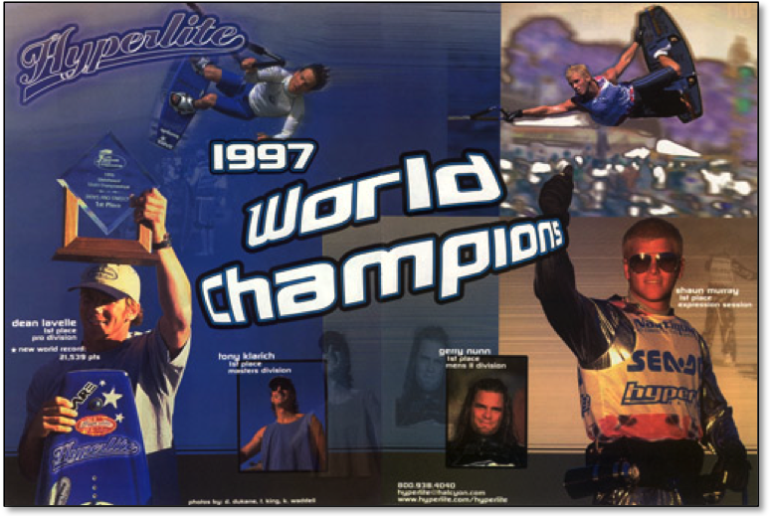
My only ink in Wakeboarding Magazine would be paid advertising - Ouch!
Dean Lavelle, Shaun Murray, Gerry Nunn, and Tony Klarich.

It took me a while to cool down, but in the months and years that followed I finally understood what Tom was getting at. There is a difference, and it’s o-kay. I really don’t want to get boxed into any one aspect of our amazing sport. Riding behind a boat offers so many ways to ride. Why get hung up with such a narrow view? Why not do it all? And that’s just what I have done for the past 40 plus years.
Which leads us to why I am telling this story. In considering the history of water skiing I have a unique perspective. My “glory days” of skiing in the 1980s and 1990s coincided precisely with the revolutionary transformation of the watersports industry. As a rider who was willing and able to try anything I became a witness and participant in the key developments and breakthroughs of hot dogging, kneeboarding, wakeboarding, hydrofoiling, and much more.
My uncle, Mike Murphy, was the original hot dogger on a slalom ski. I followed his lead, and my big break in skiing came immediately after I became the first person to ride away from a front flip on a standard slalom ski. Uncle Mike was also the co-inventor of the kneeboard in 1972. The family tradition was well represented as I went on to make my mark as a top competitor, riding the wave as kneeboarding became the hottest thing in watersports. Mike co-invented the Air Chair in 1989, and again I had a front row seat to experience the thrill of inventing new ways to fly. There have been so many adventures, so many friends, and so many good times around the world. Now, because of many friends and their encouragement, it’s time to share them with you.
But please remember:
I ski, but I’m not a skier.
I kneeboard, but I’m not a kneeboarder.
I foil, but I’m not a hydrofoiler.
All of these are labels that can only serve to limit us, and put us in neat little boxes that define exactly who we are, what we should do, how we should dress, and how we should act.
There are no boxes for this waterman.
I have tried it all in skiing; been fortunate enough to win a few championships, traveled the world, and met my wife-to-be at a boat show in Boise. Through it all I have uncovered some secrets to skiing success: have fun, be true to yourself, and enjoy the ride: wherever it may lead.

Tony Klarich
December, 2010

A TURNING POINT - THE SLALOM SKI FRONT FLIP
1984. I am being watched. Not by Big Brother, but by tens of thousands of guests each week at the Magic Mountain Water Ski Show just north of Los Angeles, CA. My name is Tony Klarich and I am 19 years old. In between performances as a professional show skier, I work obsessively to become the first person to land a front flip on a slalom ski. I rack up hundreds of attempts, each one ending in another butt-bruising crash. But I KNOW that each set behind the boat on the pond-sized Mystic Lake brings me closer to my dream.
So here I go again:
Deep-water start in the backstretch.
Go wide around the turn, just a few feet away from the menacing Gunnite edge.
Cut to the right as the boat straightens out.
Just miss the dock and pull out hard.
Wait for the boat to get up to 31 mph, then cut back to the wake.
Jump and pull the rope to my stomach as hard as I can.
Stay against the rope, and flip in the same direction that I take off from.
Have no fear…
Splat! I am down yet again. I am frustrated. I am mad. In fact I have every emotion. For two years I have been on a serious mission to land the front flip. Gymnastics, springboard diving, and trampoline…now I am finally closing in on the kill. It’s just a matter of time. For weeks I stay late to practice after the last show. My butt and legs hurt from all the pounding. Again, again, again.
At the 850 feet by 150 feet show site I have discovered that a skilled driver has a huge impact when learning a new move: especially this one. My driver, fellow skier Roger Welling, is at the helm of the Ski Nautique. We have decided that he should chop the throttle completely, just after I initiate the flip by pulling the line. So he stays off the gas, all the way to neutral, until I land, then powers up bit-by-bit. This is the same technique we use to teach front flips on two skis off the five and one half foot jump ramp.
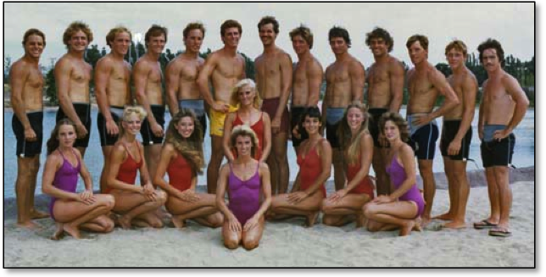
Magic Mountain water ski show: team photo, 1983.
Roger Welling, fourth from left. I’m in yellow trunks.

I slip my right foot into my 66 inch O’Brien World Team II slalom ski. It has a front full boot and rear toe strap. Roger is at the controls once again, and I’m glad. We don’t have a spotter because no one else wants to stay after work for free. On my first two tries I’m getting really close. I’m coming around, riding for a second or two, then popping the handle. Roger has the driving down pat, so all I have to do is concentrate on the skiing. On the third try it all comes together.
Around the corner.
Cut out hard.
Race to the wake.
I heave myself off the crest, flip fast, and land with enough speed to bounce off my backside and up onto my ski! Roger eases me up and the rope is still in my hands. Success at last! I scream in elation and pump my fist to the empty stands.
All I want to do is call uncle Mike. When I get to a phone he congratulates me, but asks how many I have made.
“Just one,” I reply.
“We’ll you’ll have to learn to land them on cue this weekend at the River,” he says. “Then it’s official.”
***
The very next weekend a who’s who of Southern California skiers descend on the Parker Strip of the Colorado River for the wedding of my good friend Mike Mack and his longtime sweetheart Vicki. There is plenty of skiing and partying.
Uncle Mike wastes no time getting me behind a boat and loading it up with people to make the wake bigger. People want to watch and the bigger wakes help. In the next few hours I ski up and down the 15 miles of the Parker Strip and make five or six more flips. It feels great to know that the front flip is “official”. I want to stop but uncle Mike is relentless. Is he training me to be “Murphy” tough or is he just showing me off? He puts me through four or five more endurance sets and a couple of hundred tries before the weekend is over, but I finally work up to a 50% success rate. Pain is good.
On the following Tuesday I visit Mike’s Water Ski Pro Shop at Eliminator Boats. Mike has a surprise. He calls me back to his office and sits me down. He smiles, and dials his phone.
“Herb, the kid is ready,” he says into the mouthpiece.
Now it’s my turn to smile. In five minutes I have a contract with Herb O’Brien of HO Sports for $200 a month, all the equipment I need, and the promise of an airplane ticket for my first trip to Orlando, FL the water skiing center of the universe. I have an appointment to take pictures with legendary watersports photographer Tom King. My life is about to change.
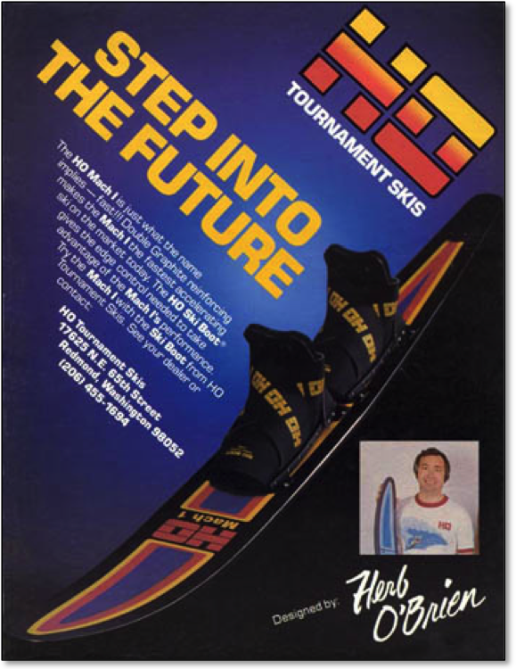
My boss from 1984-1998. Herb O’Brien, arguably water skiing’s most innovative designer. 1983 ad.

WATER, BABY
I was a diaper-wearing daredevil. My family’s home was a second floor apartment in Long Beach, CA. My playground was the community pool. I scared the neighbors by leaning myself off the perfectly good pool edge and launching face first into the water. Many good-natured adults rushed to my aid, but there was no need. I was not yet a year old, but was already at home in the water.
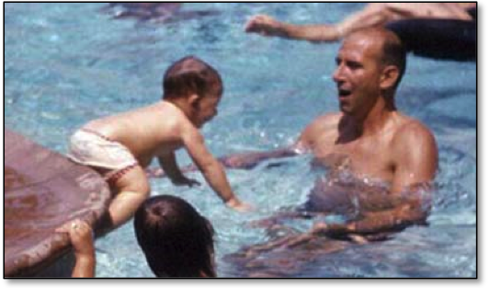
Taking the plunge into dad’s arms, 1965.

Mom and dad were indulgent with their only child. Starting in 1965 they encouraged me to swim and swim. As soon as I was out of diapers they let me spend most weekends with my maternal grandparents, Nick and Mary Murphy. Friday nights started at their modest home in Compton, CA. The evening was time to pack the van, but I was usually off playing. The van was famously known as the “Red Milk Truck”, a 1958 International Harvester Metromite that was my family’s signature tow vehicle. On Saturday morning grandma would rouse me from a warm bed in the house and I would groggily find myself a spot on the bunk bed in the red truck. Somewhere around the half way point of our 82-mile drive south I would wake up to a bacon sandwich on buttered toast. Yummy! Grandma and I always played the card game Casino to pass the time. Grandpa hummed country tunes with his best baritone.
Our destination was the Carlsbad Lagoon, a salt-water site just off the Pacific Coast near San Diego, CA. The Murphy family was a charter member of the Carlsbad Boat & Ski Club, a very active group of adventure loving people.
For my first few years I just watched as my family enjoyed water skiing. Uncle Mike and Nick had already worked as show skiers for Tommy Bartlett at Wisconsin Dells. Uncle Pat was an avid boat racer, and crack mechanic. Grandpa, the original hot dogger of the family, hammed it up on his Cypress Gardens ski, a modified jumper with an added rear toe strap and thick carpet for his back foot. He’d whip off overhead butterfly turns with double handles, and no hand wake-to-wake jumps with the rope between his legs. The white foam ski belt around his manly belly completed his showy attire. Grandma Murphy was always about endurance. She took hour-long rides on a slalom ski, throwing her head back with red hair blowing in the wind and a wide grin. I was happy to just curl up under the bow of our wood and fiberglass Powercat with twin 50hp Mercs. The gentle bouncing and sound of water on the hull was all I needed to be instantly asleep.
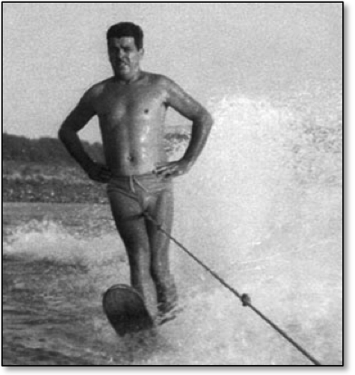
Grandpa Murphy was the original hot dogger in our family.

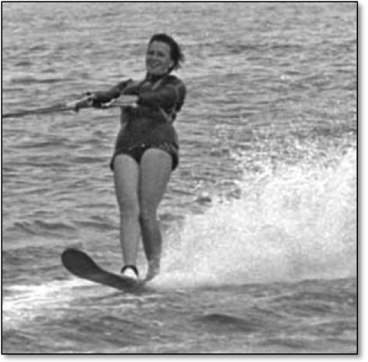
Grandma Murphy took hour-long rides!

To get a better idea of my family’s lifelong commitment to water skiing watch this entertaining 33 minute video:
“Mike Murphy, A Skier’s Life”

LEARNING TO SKI
My first experience on combo skis at age five was miserable. It started when the adults figured it was time for me to live up to “the family tradition”. I wasn’t so sure. Uncle Mike seemed to think a spin on the front of his jumpers was just what I needed to bring out the Murphy in me.
He got us up no problem, but I was not a happy camper. The salt water splashed in my face, and it burned my eyes. I cried and screamed all the way back to grandma.
A couple of weeks later fellow club member Lance Renfrow offered to teach me to ski without the boat. In 1969 this was revolutionary stuff. He promised to pull me up slowly by hand, and said I could let go of the handle at any time. I guess being in control of my own destiny was the key to my success. Lance towed me back and forth along the beach on a pair of white Voit skis tied together with a short rope. It was exhilarating! Later that day I made it up behind the boat on my first try, and ever since then I have never looked back.
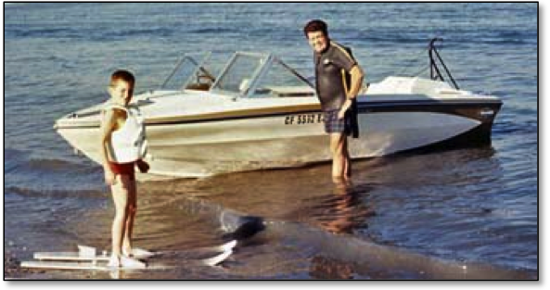
Doubles the fun in 1970 with Grandpa Murphy.

Here’s some 1969 footage of me learning to ski from a biopic that appeared on Bayliner Watersports:
Tony Learns to Ski (+ a helicopter dock start)

The following year I learned to drop a ski. Next, I went on to master stand-up beach starts, even before deepwater starts. Shore starts were a lot less pull, plus I didn’t have to dunk down in the chilly water. I was already dreaming of being a cool hot dogger like my uncle Mike. He always had cute girlfriends that were so nice to me. The connection between women and water skiing was already being molded into my impressionable young mind.
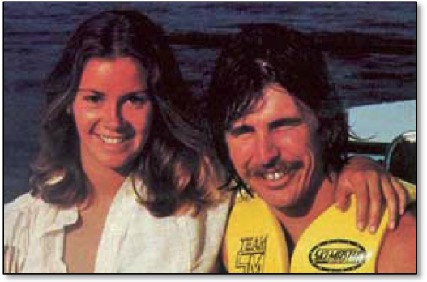
One of Mike’s girlfriends was Jackie H, a professional cheerleader for the Rams.

MIKE MURPHY AND THE HISTORY OF HOT DOGGING
In the mid 1960s uncle Mike got ski lessons from the legendary waterman Chuck Stearns. “Steady Stearns” was a family friend who taught Mike how to trick ski and pointed him towards a life in skiing.
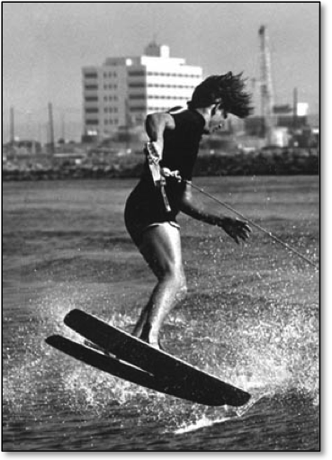
Mike, seen here doing a wake front to back, learned trick skiing and jumping from Chuck Stearns.

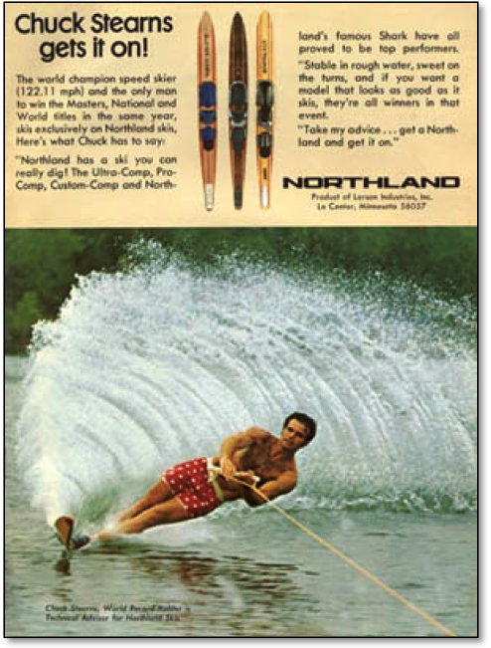
Chuck Stearns in his famous trunks. Legendary skier and family friend of the Murphys.

But Mike wasn’t satisfied with one or two types of skiing. He tried everything, from barefooting to the flat kite. Throughout the late 1960s and early 1970s he excelled in ski racing, including three first place finishes in the outboard division of the Catalina Ski Race.
The pinnacle of Mike’s ski racing success came in 1966 when he won the overall trophy at the prestigious Lake Mead 75 mile race. The second place finisher was none other than his friend and teacher, future Hall of Famer, Chuck Stearns.
Still, it was Mike’s roots in trick skiing that led him to fame as a hot dogger. At that time trick skiers scored points for various starts. Among these were the two ski backwards deepwater start and one ski backwards deepwater start. Mike learned them both. Then he heard about somebody doing a backwards start on a regular slalom ski. Mike could already do the back start on a single trick ski, so why not try it on a slalom ski, he thought. It wasn’t long before Mike had his first hot dog slalom trick.
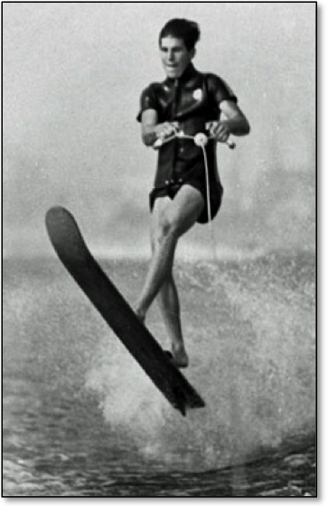
Mike was already a show off in the late 1950s.

His first original hot dog move was envisioned on the “sperm of the moment”, as he likes to say in “Murphanese”. He was on the five-foot extension off the boom working on back barefoot step offs. He had just gotten up, and was still facing forward on his flip turn ski. Mike’s focus was on barefooting, and the thought of a tumble turn popped into his head. He laid one down without even thinking it through, and came right around with the ski and all. It was so easy that he traded the step off ski for his slalom ski, and the move was just as easy. Minutes later Mike went out with a 75' line behind the boat. The tumbleturn was the first hot dog trick that he invented in the 1960s.
A year later the word was out that Butch Peterson was making a 360-degree helicopter spin on a slalom ski. Mike and another hot young rider, Danny Churchill, got wind of the move.
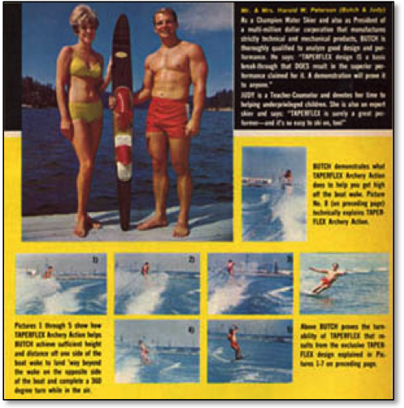
Butch Peterson poses with his wife Judy for a Taperflex ad. The sequence shots show his slalom ski wake helicopter. The Water Skier: May, 1968.

Mike rode his regular slalom ski to perfect the move, while Danny went for a 60-inch “shorty” ski. In later years Churchill used his cut down ski to make 250 consecutive helis in one ride without stopping or falling. Churchill even made an effort to promote his short ski as a new way to ride.
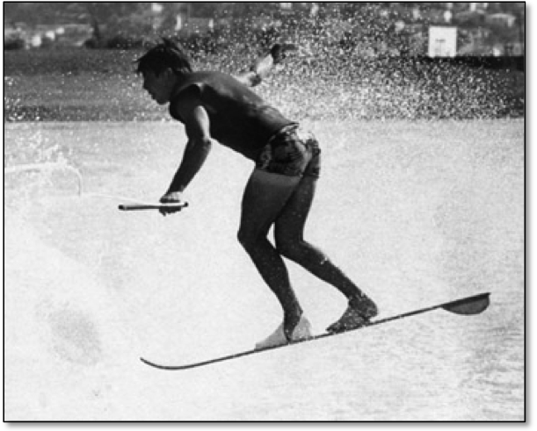
Murphy pulls a wake helicopter on a slalom ski. Late 1960s.

Meanwhile, Mike stayed on a conventional slalom ski. His next trick was a crossover from barefooting, based on his recently learned back toe up. In the barefoot version of the start he held the rope with one foot while lying on his stomach. As the boat came up to speed he planted his free foot and eventually rose to a one-foot back barefoot position. Once he imagined a similar start on the slalom ski, the transition to his slalom ski was pretty easy. He found the key was to put the foot holding the rope into the back binding to help with the strong pull out of the hole. When the ski popped up he pulled out his rear foot for better balance. Look ma, no hands!
Mike was becoming well known on the West Coast as an accomplished skier, so he decided to open his first ski school on the Colorado River in 1976.
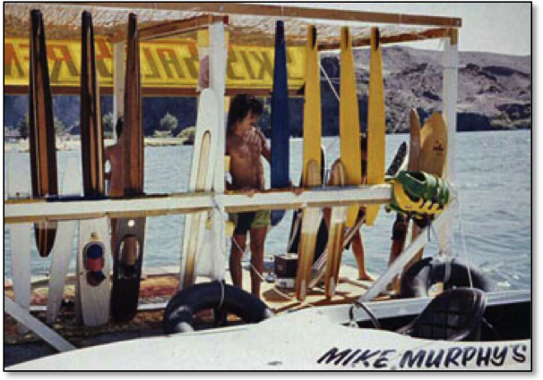
Mike’s Ski School at Big Bend Resort on the Colorado River.

His transition to businessman did not mean that his days of innovation and competition were over. Now he had a base to build on. In 1978 I watched as my uncle Mike won first place at the Endo’s International Speed Skiing Championships in Long Beach, CA. He relied on raw talent, pure nerve, and a personal bet to smoke the competition with a blazing speed of 118.92 mph!
Mike’s victory got the attention of the newly-started Spray Magazine, based in Florida. Spray named Mike its Superstar in July, 1979 and he scored a seven-page story with over a dozen spectacular pictures. He was hot dogging on his new Ski Master 67-inch ski, back barefooting, carving a huge wall of water on a kneeboard, and looking macho on his speed ski. The article was his big break. The story, and an appearance in the classic water ski movie “To Be On Top”, established Mike as the premier hot dog slalom skier and one of the world’s best all around skiers.
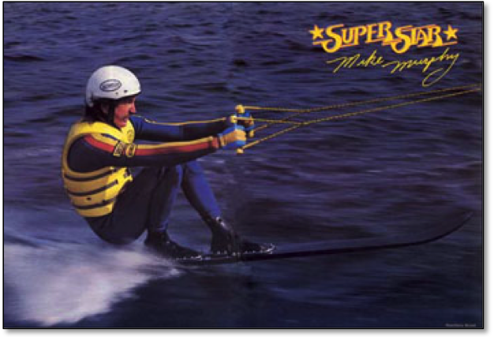
Mike showed his abilities as one of the world’s best all-around skiers.

See more photos from Mike’s breakthrough article here:
Mike Murphy, Superstar (Spray: July, 1979).

STRIVING TO WIN
My introduction to competition came in the form of swimming. From age five to ten I was a member of the Phillips 66 Swim Team. We practiced for at least two hours almost every day, and had swim meets on most weekends. My parents carted me all around Southern California in our navy blue Volkswagen Beetle. After each event I would come home with an armload of trophies, ribbons, and medals. This is where I developed the association between how hard work could translate into being a winner. I loved the feeling of being in first place and was always striving to set another pool record in my age group.
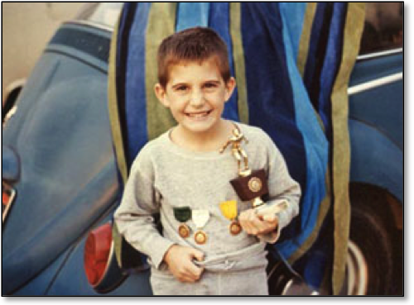
Winning in swimming felt good, 1969.

After five years of swim team the grind of practice and competition took its toll. I wanted to spend more time playing soccer and have free time to take more weekend trips water skiing. When I broke the news to mom and dad that I planned to quit swimming, I was relieved that they supported my decision. They had sacrificed so much. I was one of the best swimmers for my age, and had a promising future, but the love was gone. The long hours that it required to stay on top outweighed the thrill of yet another victory.
So I moved my competitive focus to soccer for the next several years. My favorite position was center halfback. As in swimming, I always worked hard at practice. Even then, without knowing it, my aim was constant improvement. Every drill was a competition to try and win. Every game was another opportunity to turn long term concentrated effort into success.
School was something I enjoyed, especially math. My mom was a grade school teacher who always had some learning opportunity available for me. She always saw to it that I had time on the newest computers, way back when a floppy disc was actually floppy. I’ve always loved to read books of all kinds. Hardy Boys, Willy Wonka, and the Life Nature Library series were my early favorites. Books on space fascinated me, and after watching the 1969 moon landing on our black and white set I wanted to be an astronaut for a long time.
I grew up playing Scrabble and Perquackey, both fun word games. The adults usually let me win, but I was on to them. I was always trying to get in on the “Dictionary Game”, which most people know as Balderdash. The grown ups finally let me play, and I correctly wrote down the definition for a word that I had never heard of: some South American woven material. The family was shocked and mom promptly got out a deck of cards to test me for psychic abilities. I didn’t show much promise with only 2 right out of 52, but I have had a few more strange “coincidences” since then.
In 1971 we moved from Long Beach to Orange County, CA; which still had plenty of open farmland. The new house was a welcome change because I was convinced that the old apartment was haunted. Now some kids are afraid of the dark, and strange sounds in the night, but I knew there was something going on in that apartment. Years later I finally heard the truth. Our move was precipitated by what happened to mom and her girlfriend who were talking about the odd occurrences and rattling walls. As they spoke, the Queen Mary (ship) replica desktop lighter proceeded to light itself! The heavy lighter had a flint you had to roll to spark, and a button to hold down for the butane. Mom was spooked, and she submerged the lighter in our sink for a few days before finally throwing it out. It seems that my fears were founded. We found out later that the previous occupant had committed suicide right there in our apartment.
***
My penchant for individual competition also turned to chess. There was a chess club a couple miles away from home, where for an hourly fee, I hung out to challenge older players. My years of play came to fruition in 1974 when I hit the peak of my chess career: I won the Orange County Championship for fourth graders. It was sad to have peaked in chess at nine years old, but I had bigger competitive events in my future.
A couple of years later, in 1976 at age 11, I read my first “adult” novel, the 706-page Roots by Alex Haley. That story really touched me, and opened my eyes to a much bigger world. For months I was deeply affected by the story. I felt some strange connection to the African jungle and its dark mysteries.
The year 1976 was also the US bicentennial, and mom and dad decided to celebrate by taking me, their only child at the time, on a month long transcontinental vacation. We loaded up the sky blue Chevy Nova, 8-track player blasting “Crocodile Rock”, and headed out for the National Parks in Arizona, the St. Louis Arch on the banks of the Mississippi River, and to visit relatives near the Great Lakes.
We made our way to New York City and the top of the Empire State Building. On Ellis Island I learned about how my paternal grandparents came through immigration on their way from Vis Island in the Adriatic Sea to San Pedro, CA and a better life. It was awesome to climb the cramped stairs inside the Statue of Liberty and take a few minutes to gaze over the skyline of NYC from inside Lady Liberty’s crown.
As we headed back west during that summer of 1976 people everywhere were celebrating 200 years of American independence. There were parades aplenty. Flags and fireworks helped express the warm feeling of national unity. We visited the fifty-foot faces of Mount Rushmore and the Old Faithful geyser at Yellowstone. What a trip! One memorable place was the Corn Palace in Mitchell, SD. I never knew you could do so much with corn! The wall murals made from colorful kernels were spectacular. People do amazing things with the desire and dedication to have a dream and follow through! The whole trip infected me with wanderlust, which was perfect for someone who was destined to travel the world as a professional skier.
But before one can go pro, one must have their first real ski. I caught site of my first ski leaning against the wall behind the Christmas tree at grandma Murphy’s house. Uncle Mike picked out the perfect ride for an aspiring hot dogger. He always gave cool gifts, and this one had a big red bow.
My new ski was a wooden square back made by Brad. It had a real front boot made of thick black rubber. The back toe strap was a little too big, but he said the gritty black sandpaper would help to hold my foot in. Now I really wanted to be like Mike.
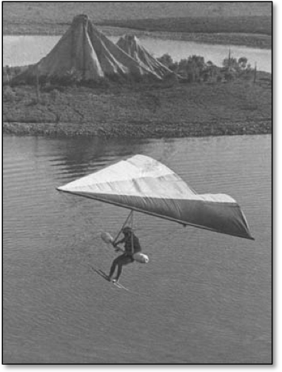
Mike soared high over Marine World on Bill Bennett’s first delta wing kite in the US.

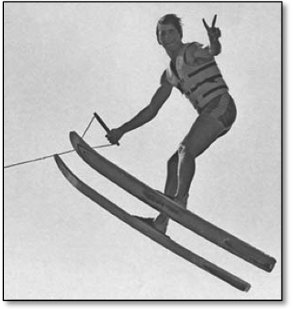
Mike was an early member of the prestigious Century Club, but showing off always came first.

The years that followed were full of fun trips to the Carlsbad Lagoon just off the Southern California coast. My new ski was a dream come true. I learned how to jump the wakes. Mike taught me how to show off whenever he was able to return home from his international adventures. He always saved the big moves for other boats or for show passes in front of the main beach. I saw Mike break 100 feet on jumpers, and become a member of the Century Club. Mike was always at the center of exciting ways to ski: the kite looked scary, barefooting seemed impossible, and two slalom skiers criss-crossing back and forth behind one boat was thrilling. He said I was ready to learn my first real hot dog trick, a backwards landing. He told me what to do, and every time from that day forward I vowed to try it whenever I ended my slalom ride. Grandpa didn’t let me do sets of landings, so it took me a few months of trying at the end of each ride. I can still remember that first fantastic finish on the south side of the lagoon.
I jumped. I turned. I skied.
Backwards!
Now I was an official hot dogger.

CH-CH-CH-CH-CHANGES
In the fall of 1971, members of the Carlsbad Boat & Ski Club opened the world’s second man-made ski lake. My first ski instructor, Lance Renfrow, was one of the original five developers, and he designed the red, white, and blue skier logo that became the distinctive design for Wet Set Village. Lance was also the one largely responsible for engineering the lake specifically as a water skiing community, complete with underground water and sites for homes. The lake was wide enough for a jumping event, the shores were angled just right, and the shape of the turn islands knocked down the waves. Now the Barstow area in the high desert of Southern California had the world’s first two man-made ski lakes; Jack Horton opened the first in 1969.
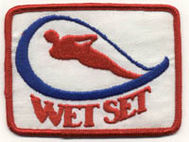
Wet Set Village was a revolutionary new place to ski.

We made a few visits to Wet Set Village, but our family was more about show skiing than tournament skiing. The Carlsbad Club became the Wet Set Boat & Ski Club, but we didn’t join. My grandparents decided our new ski spot would be the Long Beach Marine Stadium; just a short ride from my grandparent’s new home in Los Alamitos, CA. The Marine Stadium was a man-made saltwater channel about a mile long and 150 yards wide. It was built to host the rowing event for the 1932 Los Angeles Olympics.
The Marine Stadium became our new favorite place to ski. I was finally old enough to be the observer, so grandma, grandpa, and I went to the Stadium 40 or 50 times a year, rain or shine. In those days we parked right on the beach, and the red milk truck was a sign to everyone that the Murphys were skiing. With my uncles Mike, Nick, and Pat, and all their friends, there was always a great variety of characters stopping by to hang out or trying to “leech” a ride. Our hamburger and hot dog barbeques were famous, and you could always count on grandma’s delicious homemade cookies.
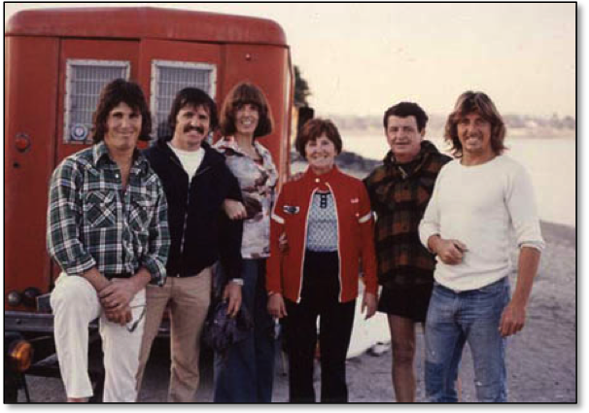
The Murphys: Mike, Pat, Mom, Grandma, Grandpa, and Nick.

During the winters we had the place all to ourselves, but the summers got crazy with wall-to-wall boats in the water and cars with trailers on the beach. When Mike came to town grandpa worked the crowd, making conversation with everyone about the exploits of his world famous son. Sometimes “the old man” talked to every group on the entire beach, and asked them to stop skiing for a few minutes so Mike could perform a flying barefoot start. Barefooting was still a big deal in those days, and the crowd loved it.
It was around this time that I got my first wetsuit. Back then you couldn’t buy a kid’s wetsuit, so grandma made mine by sizing down one of Mike’s old suits. The whole thing was held together with neoprene glue, and it had to be repaired after each day of riding. But grandma Murphy didn’t mind the effort: it kept me skiing through the chilly winters. The Murphys took pride in riding in all conditions: fair or foul, rough or smooth. Sometimes we skied “for the birds”, as grandma would say, and sometimes it was like we were putting on a ski show for a crowd of hundreds.
By now I was taking hour-long sets, taking a few laps on each of my various pieces of equipment; my trusty Brad ski, the Knee Ski (which Mike co-invented in 1971), shoe skis, trick skis, and a pair of stand up hydrofoils.
I trained on trick skis with an eye to learning Mike’s wake 360 on my slalom ski. Of course I learned all the basic surface turns on tricks, but my style of riding included a lot of free riding, with wake-to-wake jumps, daffys, twisters and the one-handed spread eagle. It was always about having fun and showing off.
Learning the helicopter on two trick skis was a huge stepping-stone to doing it on a slalom ski. I never considered the slalom ski heli to be an impossible move, because I saw Mike do it for years. When it was my turn to try, it was not a matter of if, but when I would do it. I was expected to learn the heli and I did. Mike was proud that I could make one of his signature moves, and he would always ask me how many I made on each ride. Then he would always make sure to do a few more. Our lifelong friendly competition had begun, and people started to take notice of the kid who was Mike Murphy’s nephew.
One day Mike brought down his boat with a huge pole sticking out from the side. He informed me it was time for my first barefoot lesson. Unfortunately nine out of ten colons agree that it’s not a good idea to do learn deepwater barefoot starts in a flimsy, pieced together wetsuit. Later that day I gingerly donned the best alternative: a pair of tight jeans shorts over a Speedo. I floundered around for a while, getting another nose full of water and a handle to the top of the feet. When Mike saw I had put forth sufficient effort he tossed me a kneeboard. He thought I should go straight to the deepwater start so I didn’t get “sissified”. Eventually I learned to “walk on water” with confidence, and in a few months I was the one grandpa was bragging about to do the flying beach barefoot start.
Water skiing was my refuge in junior high school. It’s hard enough just being a teenager, but I was also attending a school out of the district because my mother was a teacher there. The rich kids of the beach city were mean at times. I was the kid who didn’t have the cool clothes or stylish haircut. I shrugged it off with athletics, being only one of a few students who lettered in all six available sports.

ON THE MIGHTY COLORADO RIVER
In the mid 1970s Mike opened his first ski school at Big Bend Resort on the Parker Strip of the Colorado River. Grandma and grandpa became River Rats too: they bought property a couple hours north in Topock, AZ; just across the River from Needles, CA. It was a secluded ski spot with smooth water that seemed far removed from the crowds and party atmosphere of the Parker Strip.
The Colorado River was wet and wild in the 1970s, and Mike was a celebrity on the Parker Strip. He put on weeknight ski shows with the best local talent to promote his shop and school. He gave lessons all day and at night the bars were just a boat ride away. Sundance was the waterfront bar known far and wide as the place to get crazy.
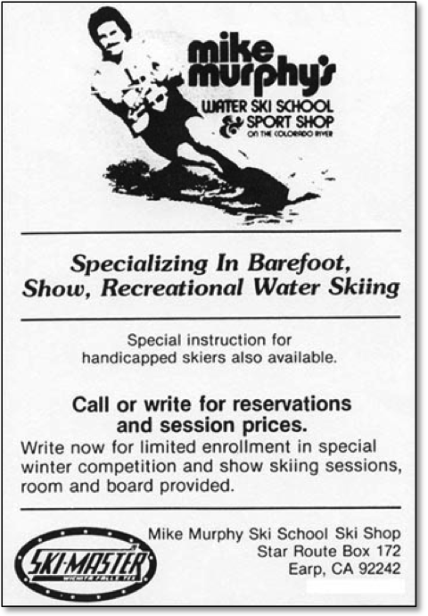
Mike’s place on the Colorado River was the original “Hotdogger’s Hangout”.

The house downriver from Sundance was a local landmark too, with a roof made of grass! It looked like an overgrown lawn. The residence belonged to Clay Jacobson, inventor of the Jet Ski. When you knew who the owner was, it made sense that such a innovative guy would have a creative way to keep his house cool during the scorching summers.
The world’s first Jet Skis were in my playground, and I had a few rides on the early stand up models by Kawasaki. Unfortunately my personal watercraft (PWC) days came to a quick end after I split my chin open on the handlebars.
While the adults were enjoying the free spirited party atmosphere of the Parker Strip, I was under the watchful care of my grandparents. We spent a day or two with Mike, then pulled the boat and headed upriver to the calmer waters of Topock, AZ.
Our ski spot in Topock was in full view of the I-10 freeway bridge as it crossed high above the clear, blue water. I was working at getting better on all my rides. Grandma decided it was time to get serious about taking some film and photos of her grandson. The water was glass calm, the light was perfect, and I was skiing well. She shot four rolls of film with her Super 8 camera, and followed it up with three rolls of slide film. The perfect conditions and relaxed atmosphere allowed us to capture my first good images as an up and coming skier.
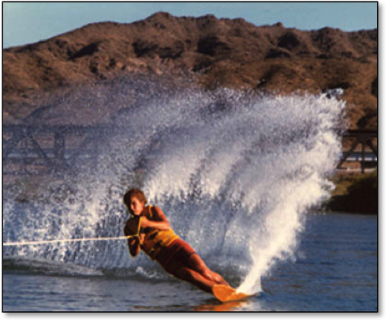
Carving a turn on my beloved Brad ski. On the Colorado River near Needles, AZ: 1979.

I was fortunate that grandma was a shutterbug. She always had cameras on hand to take shots of the whole family. Everyone looked forward to sitting down and watching her films after the red truck was unpacked and the boat was washed. Thanks to grandma I have film of my first ride on the front of Mike’s skis. I also have a photo of my very first ride behind the boat. While it is much more common now for parents to capture every “first” moment of their child’s lives, in the 1960s and 1970s it was not the norm, especially with film.
The weekend of my big photo shoot at Topock was also a milestone for grandma Murphy. She always wanted to get a ski ride with a grandchild driving the towboat, so all that week she gave me daily boat driving lessons. With smooth water, and no other boats to distract me, grandpa felt better letting us take the boat out. Grandma Murphy talked about her glory ride for years, and it finally came to pass with me, her oldest grandchild. It was hard to appreciate the significance of the moment at the time because I was more excited about just finally getting to drive the boat!
I was growing up, skiing well, and Mike thought I was ready to be in my first ski show. Our show was in between the drag boat races in Needles, just a few more miles upriver. The water was rougher than what I had been practicing in, and the boat was also different; Bill Sikes’s twin engine Hydrodyne outboard. I did have my trusty Brad Ski, but even so, the unveiling of Murphy’s nephew was a flop. I did okay with the wake-to-wake jumps, but the wake helicopter was the big trick I was expected to make. It’s never good to fall in a show, but when you go down on a first attempt, there is always a chance for redemption. After a fall the crowd knows that what you are trying to do is tough. I fell on my second try too. I hardly ever missed two in a row, but never three…until that day. The feeling of getting picked up by towboat during a show was something I never wanted to repeat. So I vowed to learn how to ride behind any boat with any driver, and in any water.
The sharp smell of vinegar filled my nostrils as we wiped down Bill’s boat after the show. Mike has always used “schmang” of 50% Windex and 50% apple cider vinegar in a squirt bottle to wipe down boats. Even now, when cleaning a boat, I’ll occasionally catch a whiff of the stuff and be transported back to that pivotal day so many years ago.
***
My grandfather was one of the proudest parents around, often to the point of embarrassment. He would chat up gas station attendants, mechanics, and beachgoers; just about anyone who would listen concerning the exploits of his offspring. He eventually created what could only be described as a shrine of posters and press clippings inside the red milk truck. Unsuspecting victims would get the wall-to-wall guided tour. But as friendly as grandpa Murphy could be, he could also lose his cool. One day, when we were visiting Mike at the River, I was getting ready for a deepwater start behind his Glastron I/O. Someone came by on a slalom ski and sprayed him with a huge wall of water. I knew it was trouble, and I also knew that if I didn’t make that start I would be swimming a long way home. Grandpa took off full throttle, even though I still had a few feet of slack line. I hung on for dear life, got a huge yank, and barely made it up.
The chase was on.
Both drivers had their boats at top speed through rough water for over 10 miles. We were finally coming up to Mike’s new ski shop at the Windmill Resort. It was now or never for me to get away from the inevitable confrontation. We were about 70 yards from shore so I cut out hard right, and let go well in advance to swim in with the current. I don’t know what happened when grandpa finally chased the guy down, and I never asked. It was best to just lay low when grandpa got excited, and when he gave the “Bobwhite” whistle, you’d better come running.
I got one of my worst skiing injuries during another visit to Mike’s shop on the River. The rep from Western Wood Skis was calling on Mike, and a perk of his job was showing off the product. He took his pair of wooden trick skis out for a fun ride. This guy flew through the air with huge jumps and great flair. It seemed so much more exciting to me than what people usually did on trick skis. I did a few moves on the trick skis, but I wanted to ride like that! After his show was over, it was Mike’s turn to show me off. In the mid 1970s barefooting was still something of a feat on the West Coast, especially at my age. The water was way too rough, but there was no way I could say no. I fought the waves for 25 yards, then planted my foot through a roller and went straight out the front. I landed squarely on my chest and my legs folded up toward my head. The pretzel position severely hyperextended my lower back. I was down and out for over two weeks, my back hurt for months, and it bothered me on and off until I went to Chiropractic College in 1989.
A few years later, when I was 16, my mom finally let me spend a month on my own at Mike’s ski school. The shop floor was patch worked together with rectangles of sample carpet in various sizes and colors. Mike had the most of the ceiling covered in water ski posters: Bob LaPoint carving a serious turn at night on his Maha ski, Wayne Grimditch upside down off the ramp on a pair of short jumpers, and some old guy with a beard standing in a meat market holding a Connelly Hook. “Psst…Wanna buy a hot ski?!” was the caption. (Click here to see Bob, Wayne, and the Hook) The whole shop was overflowing with the smell of fresh rubber and all the latest equipment. It was less than ten feet from his front door to the water, and I tried riding every piece of equipment Mike had in the shop.
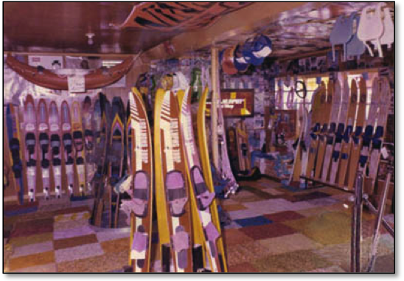
Inside Murphy’s Ski Shop at the Windmill Resort, circa 1980.

At first I was assigned to watch the shop while Mike did lessons. He taught me how to run the register and repair bindings. Mike also sold his own handles and ropes, so assembling “Murphy’s Ski Lines” became my main job whenever there was nothing else to do. I put together thousands of ropes and handles for him over the next three years.
My first brief stay at the River was not long enough to tarnish my Catholic school upbringing. I attended Servite High School in Anaheim, CA from 1978-1982. The all-boys college prep school offered an outstanding education and great sports programs. The lack of girls in class was very effective in helping young men with raging testosterone to focus on their studies.
The leeway given to our instructors in the discipline department was effective for keeping us in line. If you screwed up, you could end up kneeling on a tile floor for the entire class, or maybe have to do a set of pushups on the spot. It was just enough to keep you on your toes, and we learned that messing up had real consequences.
Intramural sports offered some short-lived comedy relief from our intense studies. One team called themselves “The Nads”. We cheered loudly for them during the lunchtime competitions, “Go Nads! Go Nads!” Another hilarious team name was “With Themselves“. The morning school-wide PA announcement was something like “the Monarchs play With Themselves” today at lunch. Classic.
In school I played a couple of years of basketball, then switched to soccer for my last two years. In my senior year our team went to the CIF finals, but lost the Championship Game that we really should have won. Whatever the coach said about our great season, second place did not feel good.
In 1981 Servite completed construction on a state-of-the-art theatre with room for a thousand people. I danced and sang as a New York gangster in “Guys and Dolls”. It was a small role, but the stage experience afforded valuable lessons for my future endeavors as a performer. Singing was my thing, so I also participated in the inaugural year of the Servite Men’s Choir, directed by Larry Toner. Coach Toner insisted that some of his football players become singers, so being in choir ended up being cool. Coach Toner was my biggest mentor at school. He spoke and taught several languages, and his memory was like a steel trap. One time in his class we had to memorize a long poem in Spanish. I could only recite the first part, and knew it would be extra work if I didn’t get creative. So I performed the first stanza while standing on my head in front of the class. I actually got a compliment for my performance, and more importantly, no punishment.
My junior year brought an unexpected surprise. Dad picked me up from a day of Boogie boarding at Sunset Beach.
“You know that trip mom and I took to Vegas?” he asked.
I nodded suspiciously.
“You’re going to have a baby brother or sister,” he said.
It was shocking after being the only child for 15 years, but the trip to Vegas explained it all: I was conceived there too.
My little sister Kathy came in due time, and the pressure was off. When it was time for me to move out of the nest it wouldn’t be empty.
My first “real” job at Farrell’s Ice Cream Parlor was with my best friend Chris Carlyle. The only normal thing at Farrell’s was punching a time clock. We publically awarded ribbons to people who consumed “The Pig’s Trough”; a six-scoop banana split with all the trimmings. We banged the drum and clanged the bell while two guys ran up and down the aisles to deliver a 30 scoop frozen concoction called “The Zoo”. I just couldn’t get away from being an entertainer.
With a few bucks in my pocket, I organized my first paid photo shoot. I hired a Servite classmate who was the resident yearbook photographer. Even at that early age I realized the importance of owning and controlling your own pictures. I paid Victor Davila $100 plus expenses to come down and shoot at the Marine Stadium. Of all the photos from that day, my favorite is a simple shot. I rode on a pair of stand up hydrofoils with my hand extended over my head and a “wow” expression on my face. It really expressed the pure joy of riding.
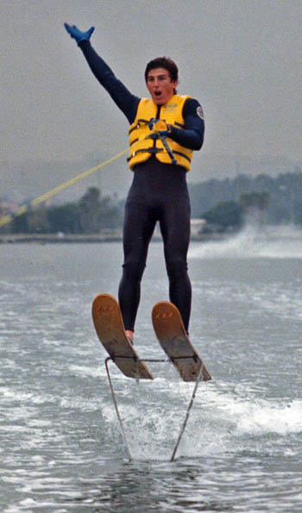
Showing off for my first paid photographer, 1981.

Two decades later Victor was at the center of another “coincidence”. I was shopping at the local big box store on the day of my 20-year high school reunion. My son and I were cruising the toy aisle when a brightly colored box on the top shelf caught my eye. The product was a cross between the Easy Bake Oven and a kit for a mad scientist. It was a “toy” designed for boys to create edible candy bugs. I thought to myself, “what kind of whacked out mind could come up with a product like that?” I found out that night at the reunion: Victor Davila.

COMING OF AGE
Starting at age sixteen I spent two full summers working at uncle Mike’s ski school on the River. I lived in uncle Nick’s trailer, and rode my skateboard down the hill to get a ride to work: a ski ride. “Today Tony, today,” was one of Nick’s favorite phrases as I rushed to suit up.
Mike and Nick never let me forget how I showed up as such an innocent kid, pocket Bible always at the ready. They were out to teach me the ways of the world, and to some extent they succeeded. Nick loved to put on his best southern preacher voice and go through the fire and brimstone routine. When he got to the tremulous line “and the Devil will reach down to grab your soul” he reached his hand down through his shorts and made a claw. “I say, I say Hallelujah brother!”
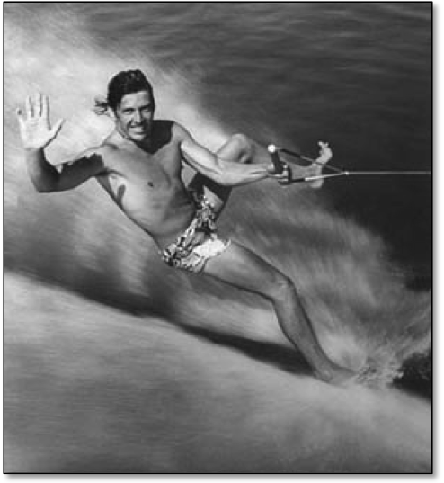
One of uncle Nick’s best pictures from the 1970s. This one hung on the Ski Shop wall for years.

The equipment rental program at Mike’s shop was a great deal for skiers. For 20 bucks a day renters could take out anything on the dock, ride it, then bring it back to try something else. Mike also gave hundreds of lessons each summer, often with the help of Mike Mack. Mighty Mack was a long time surfer, and that influenced his ski style. When Mack made a slalom turn he often took his inside hand off the handle to touch the water. Mike and Nick made fun of his unorthodox turning style. But Mack kept at it because he said it reminded him of surfing down the face of a wave.
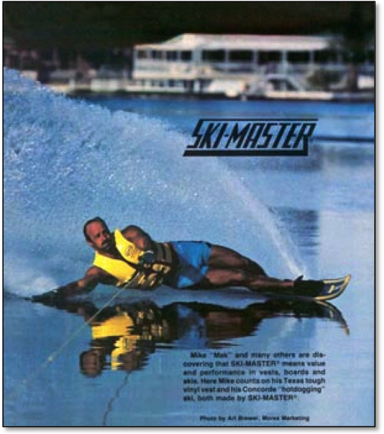
Mack’s unorthodox surf-style turn on the Ski-Master Concorde.

One day, on the glass calm waters in front of River Lodge, Mack really laid into a turn with his inside hand on the water. He got so low that his ski slipped out. All of a sudden he was sliding on his side, with his inside hand helping to control and support his weight. The Bodyslide was born, and it instantly became Mack’s signature move.

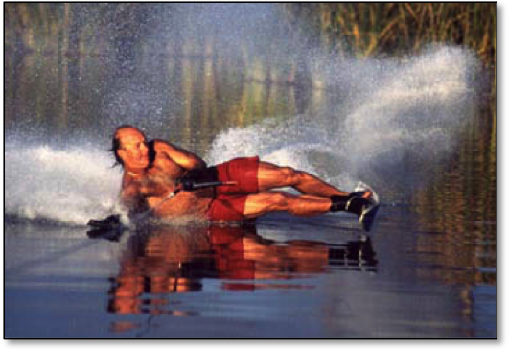
Mack’s signature move came from surfing.

I have another memorable image of Mack at the ski shop, reclining in pain after a big night out. He was lying on the floor in recovery mode, perfectly content to use an anchor for a pillow!
Mack and I were on the low end of the totem pole, and our grunt positions kept us together. Mack hustled to make it on the River, and was an excellent mentor for how to succeed by working hard. He lived in his car for the first couple of seasons, which everyone called the “Nova-Inn”. He detailed vehicles, washed windows, and was the resident barber. Just trim and swim. In between all of his hustling Mack spent extra time teaching me the ropes as a boat driver and instructor.
When it came to giving ski lessons, everyone at the shop used Mike’s unique method of instruction. For beginners on a slalom ski that meant we got in the water with new students. The instructor wore a pair of trick skis, and positioned themselves behind the students while holding onto both ropes: a single handle in one hand, and double handles in the other. Most students learned on one ski, even if it was their first time on the water. It was easy to pop up behind a kid; you could use your strength to pull them out of the water. The bigger guys were tougher. Mack usually got the big boys, while Mike reserved the hot chicks for himself.
Once we were up with a student, we got them into the proper ski position, passed them a handle, and stepped around to lend side-by-side support.
Mike, as the creator of this technique, was also the master. I saw him get hundreds of students up for the first time. They went from being in the water, to skiing on their own in less than 30 seconds. Viola! It was some kind of water skiing magic trick that never failed to amaze the student or their friends and family in the boat.
***
Mike was sponsored by Ski-Master, so everyone in Mike’s inner circle was riding their product. It was finally time to trade in my trusty Brad square back for the hot ski of the summer, the Concorde. The Concorde was 68 inches long and extra wide through the tail, perfect for hot dogging or relaxed cruising. It was one of the forerunners to the explosion of wide skis made popular in the 1980s. I rode one the next four years because of Mike, until I got my first real ski sponsorship.
Our River crew frequently spent the afternoons skiing the slalom course on Big River. Uncle Nick especially enjoyed taking everybody down to the secret spot. It was off the main River, hidden by reeds, and the entrance was so shallow that the only way to get in was at full speed. We had friendly rivalries, challenging each other at 28 and 32 off, sometimes even getting a few buoys at 35 off.
On one trip to the secret spot Mike and I decided to focus on back barefooting. John Clemmons, top competitive barefooter in the western region was our instructor. I had never back barefooted before, so John had me trying back deep starts on the boom. I found it amazing that your chin created an air pocket that kept you from getting a nose full of water during the initial start. It was always a shot of water up the nose on a slalom ski back deep if you didn’t blow bubbles. After a dozen or so tries, and a mild case of whiplash, I figured it out.
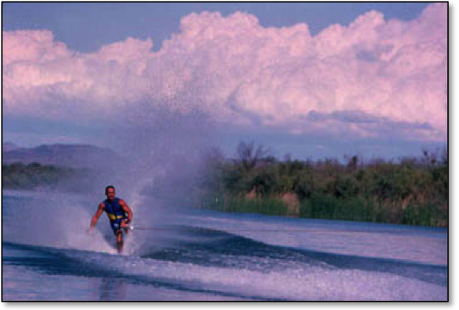
Our barefoot instructor John Clemmons at the Secret Spot.

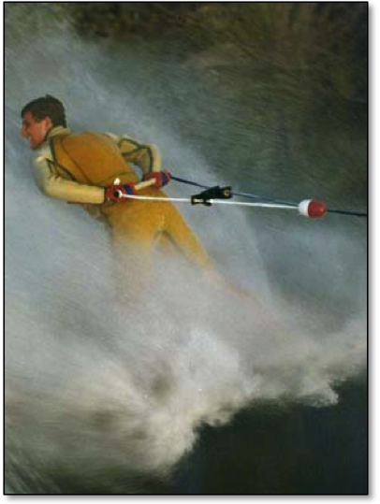
My first backwards barefoot ride, 1982.

Now it was Mike’s turn.
If I was doing a back barefoot start on the boom, then he would have to do one long line. It was the old one-upsmanship. Mike was already an accomplished back barefooter. He could do back toeholds long line, and a back toe up on the boom; but getting up backwards behind the boat was a pretty tough trick. He tried and tried for more than two hours. It looked painful, and after a while we tried to talk him out of it. We were hungry! But Mike’s stubborn streak would not allow him to quit. It was getting dark and his falls were getting ugly. Finally, at the last light of day, he pulled one off. Mike was so proud of himself that night at pizza dinner, and deservedly so, because it was one of the most determined sets of skiing I’ve ever seen.

BE LIKE MIKE (AND A FEW OTHERS)
I grew up around hot doggers, and that was always the kind of skier I wanted to be. Uncle Mike was by far my biggest inspiration. I watched and learned from Mike for many years. Mike was the first skier known primarily as a hot dogger. It started with his appearance in the 1978 classic water ski movie “To Be on Top”, sponsored by Connelly Skis, Ski-Master, and Correct Craft. That movie got Mike the first full-page ad promoting hot dog slalom skiing for Connelly.
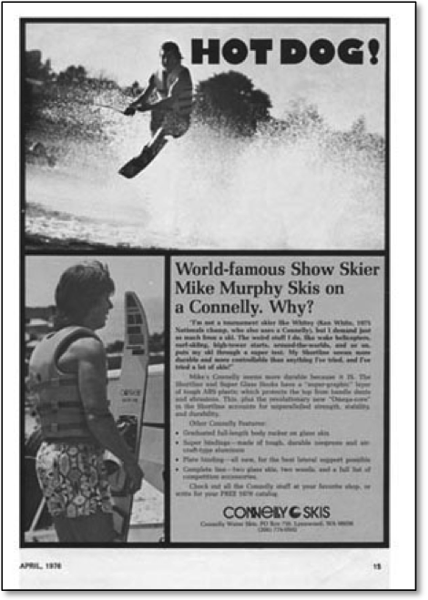
Mike made big news with the first full-page ad featuring Hot Dogging on a slalom ski. The Water Skier: April, 1976.

See Mike’s Hot Dogging highlights on YouTube:
“To Be On Top”

“To Be On Top” also got Mike a poster deal with Texas Recreation wearing one of their “Super-Soft” vests. “Mike Does It All” was the appropriate headline on the poster. When Texas Rec began producing a new line of skis under the name of Ski Master, Mike jumped full in. Ski Master started running a series of full-page color ads featuring hot dog slalom skiing with both Mike Murphy and his ski school instructor Mike Mack. My uncle was the one who led the way in defining a new way to ski: hot dogging.
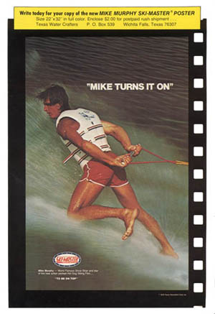
Mike was the main man for Ski-Master, so we all rode their product.

See another full-page color ad featuring Mike Hot Dogging (scroll down). (The Water Skier: June, 1981):
Join the Fun Filled World of Ski Master

But there were a few other skiers who caught my eye in the years before I went pro. In the 1970s I perused the pages of The Water Skier, the official publication of the American Water Ski Association. As the publication for the governing body of water skiing in the United States, The Water Skier concentrated mostly on tournament skiing. My grandparents subscribed to The Water Skier, so I usually thumbed though the predominantly black and white pages whenever we went skiing at the Marine Stadium. Every once in a while I found a picture or story to dream about.
In 1977 the water skiing landscape changed dramatically with the introduction of Spray Magazine. Spray was for all skiers, not just those who participated in tournaments. It’s pages were filled with large colored photos featuring all that skiing had to offer.

An early article that inspired me; the photo heavy report from Spray; July, 1977.
First National Freestyle Jump Championships

Ricky McCormick became the first skier other than uncle Mike who really sparked my imagination. I knew that Ricky was making flips behind the boat on a trick ski, but an early issue of Spray brought it to life in a two-page color spread. Ricky’s parade of flip pictures in the magazines got me dreaming about trying a flip on my slalom ski.
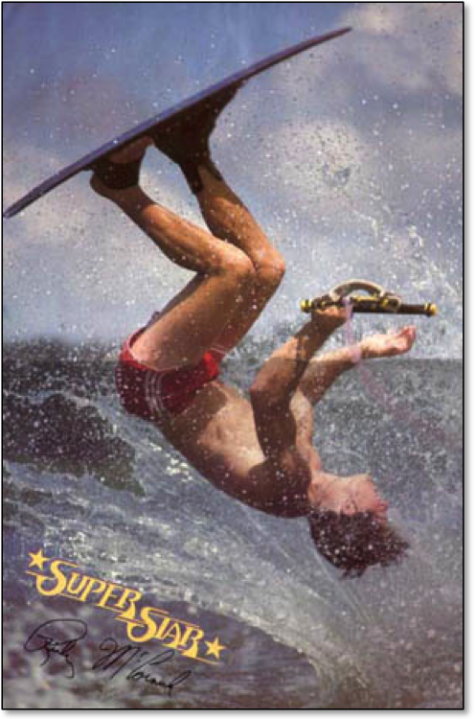
“Tricky Ricky” McCormick was the first person to flip behind the boat using nothing but the wake. Spray: Fall, 1977.

Wayne Grimditch was another skier whom I took careful notice of. Wayne rose to national fame in 1978 came after he won the Superstars competition on ABC TV. I cheered on the man who represented the sport I loved. Wayne was the David going up against the Goliaths of the traditional sports world. He took on Steve Garvey, long time Dodgers 1st baseman; Bob Beamon, track star; Tom Sneva, auto racer; and several pro football players. Grimditch beat them all in the ten-event competition, and gave a great boost to water skiing.

Read Wayne’s Superstar story here (The Water Skier, 1978):
Wayne Grimditch Wins ABC’s Superstars Competition

On the water Wayne was a very talented 3-event skier, but his real specialty was distance jumping, in which he held the World Record. At 13 years old Wayne made waves by performing a two-ski front flip off the ramp during a competitive trick pass. He later transferred those skills into the first freestyle jumping competitions. It was his skill as a freestyle jumper that interested me. Mike’s shop at the River had a poster of Wayne doing a flip off the ramp on his trusty pair of EP Aerial skis, and I spent hours dreaming about when it would be my turn.
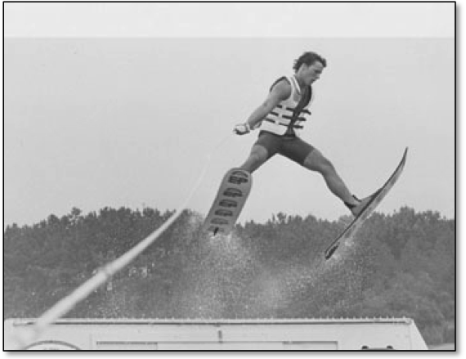
Grimditch was one of the early Freestyle Jumping competitors. Spread Eagle Helicopter at the Masters.

Click here for more info on the pioneers of flipping.
Includes timeline and story.

Spray became so popular that in 1980 Terry Snow launched a competitor: World Water Skiing Magazine. For a few years there were two publications battling for the hearts, minds, and dollars of recreational skiers. The excitement of skiing was on sale and I anxiously awaited each issue. Ron “the Raging Bull” Scarpa battled Mike “The Matador” Seipel for top barefoot honors. “Twiggy the Water Skiing Squirrel” made a cover, and Brett Wing rigged a special handle to be one of the first to do a barefoot front flip. The thrills and pageantry of show skiing was covered extensively, and I loved every page.
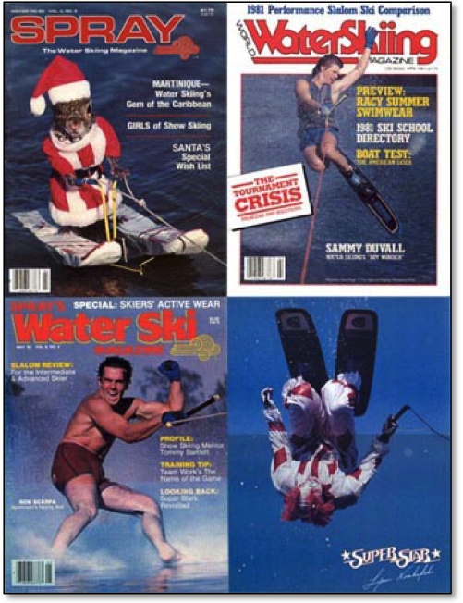
“Twiggy the Water Skiing Squirrel” makes his debut, Sammy Duvall dogs it up, Ron Scarpa bares his soles, and Lynn Novakovski rips a flip as Corky the Clown.

I always looked forward to Sammy Duvall’s photos. He was the reigning World Champion, but I was more interested of pictures of him riding a Hydroslide kneeboard or launching his famous mule kick on a trick ski. He made it all look so fun, and I desperately wanted in on the action.
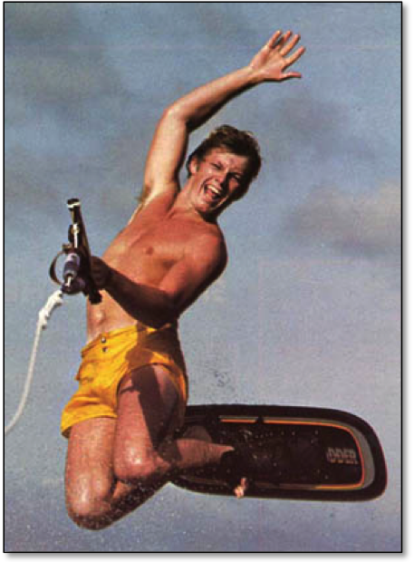
One of Sammy’s signature moves.

Carl Roberge was another three-event skier who frequently broke out of the mold to do some showing off in the early days of the magazines. Carl always looked like a hot dogger at heart. It was obvious he was always trying to add his own personality to his competitive skiing. At tournaments he delighted the crowds by performing tick tocks on his slalom ski after finishing his runs through the course. In September, 1983 he appeared in a two-page “Etc.” story in World Water Skiing doing a new trick on a slalom ski: a 360 tick tock while hanging on to the rope. I had already been making my 180 “whip-tics” for more than a year, and had mixed emotions about the sequence. Admittedly, I was jealous. He was the star and I was stuck in the back woods. I wondered if I had made my version of the move before Carl. I took some consolation in the fact that Carl did a 360, and I did a 180. Nevertheless, seeing hot dogging on the pages of the magazine lead me to believe that I was on the right track, and I was even more fired up to become the world’s best hot dog slalom skier. I kept a watchful eye on Carl’s antics in the magazines, especially his fun loving Sundeck Ads. Carl always added flair to his riding, no matter what he was doing. I could relate to that.
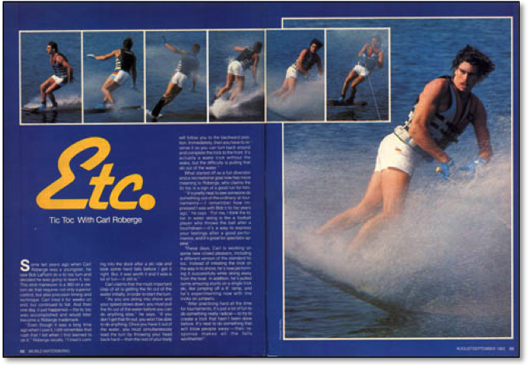
Carl Roberge broke the mold for traditional skiers by performing Tick Tocks during runs at slalom tournaments. 1983.

Click here to see some of the “Etc.” features that broke new ground in skiing, including Mike Mack’s Bodyslide, and much more.

Anyone doing a flip behind the boat caught my eye, and that was often on jump skis. Spray and World Water Skiing documented the rise of freestyle jumping competitions with Mark Jackson, Harold Cole, and Scotty Clack. This was the first group of guys to relish full time in flips, and I was glued to every move.
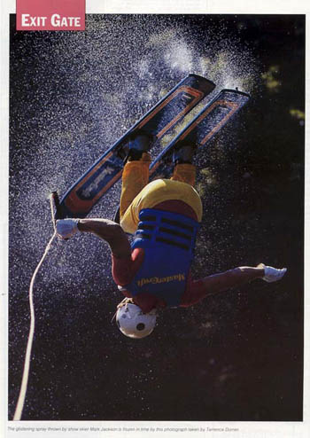
Mark Jackson was a popular Freestyle Jumper in the early 1980s.

Growing up on the River with uncle Mike as my idol taught me that hot dogging was more than just one way to ride, and seeing it on the full-color pages of magazines confirmed it. Hot dogging was an attitude and style on the water. It really didn’t matter what you were riding, it was all about having fun, and coming up with new ways to ski. I was more than ready to make my own mark.

DOG DAYS OF SUMMER, 1982
My last full summer at Mike’s Ski School was my coming out season as a hot dogger. I spent every possible moment working on tricks of my own creation. When we practiced on the course at Big River, I would end each pass with a backwards landing, rope in hand as the boat turned in and I sank in the water. A light went off in my head and I knew I could do the same thing at regular skiing speed. Why not cut out hard, just like when you shorten the line, and do the trick in those few seconds when you get slack in the line and you slow down? Uncle Nick pulled me for dozens of tries behind Betty O’s powder blue Ski Centurion. The backward part was easy. I already had that from years of landing backwards. The tough part was getting the timing just right on the 180 hop from back to front. Too much slack, not enough speed, line too tight, too hard of a cut: it took about a week to work out all the variables. I eventually found the sweet spot, and skied away from my very first new trick. I called it the “Whip-Tick”. Whip because that’s how you get set up, and tick, because it’s half of a tick-tock landing.
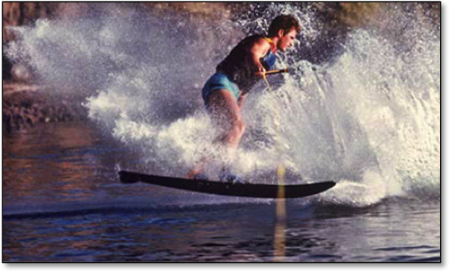
My very first original Hot Dog move on a slalom ski, 1982.

Watching uncle Mike taught me that a complete run has a beginning, middle, and an end. I had a few tricks for the middle, and a couple of cool ways to end a run, so it was time to concentrate on a new way to start. We did a lot of dock starts on the River, and the dock next to the shop was only about six inches off the water. What kind of slalom ski start could I do off that low dock? I was already making backwards deepwater starts like uncle Mike, so it made sense to try a backwards dock start.
The toughest thing to figure out was how to coil and hold the rope as the boat idled out. At first I used a second person to handle the rope so I could concentrate on the trick. I made the back dock start on my seventh or eighth try, but it took a few more sets to get comfortable handling the rope by myself. My second new trick of the summer was official. Often times the hardest thing about doing a trick that no one has done before is just thinking of it. The actual trick is just a matter of building on past tricks, and trying the new skills enough times get a feel for it.
The backwards dock start was the move that really boosted my confidence. The sibling rivalry with Mike was heating up. My favorite new phrase to direct at Mike was “over the hill”.
I had learned every one of his big four hot dog moves: the back deep, wake helicopter, tumbleturn, and backwards landing. My wake jumps were just as stylish as his too. Now it looked to me as if I was finally surpassing the master, at least in hot dogging on a slalom ski.
“Just you wait Tony,“ was all he would reply to my ribbing.
Now it was uncle Nick’s turn to give me a hard time. He told me about some guy in Texas who was doing a side slide on a slalom ski. So off I went to figure out how in the heck to do it. What about the fin? How do you go from skiing straight to the side slide? You can’t just pivot around like on a trick ski. I knew the fin had to ride out of the water, and the only place that could happen was over the trough of the wake next to the crest. I would just have to get in position next to the edge of the wake, and hop so that the ski landed sideways with the fin out of the water. I slowed the boat down to about 24 mph, and got to work. It took me a couple of weeks to figure out the hop, landing, and proper ski positioning: just past 90 degrees to keep the fin clear of the wake. Once I was able to do the move on cue uncle Nick laughed as he told me that the Texas thing was just made up. I had believed the whole thing! Both Mike and Nick thought it would be funny for me to try something that they thought was impossible.
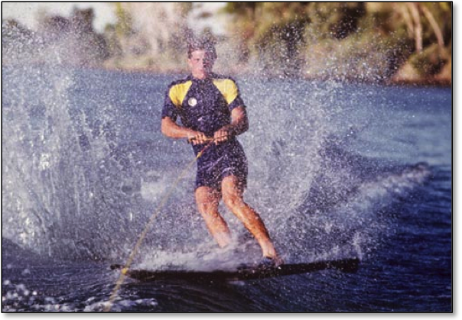
Learning the slalom ski side slide, 1982.

Now I was constantly peppering Mike with “old man”.
“Just you wait Tony,“ was his reply.
I wasn’t waiting. It was time to learn another trick. But not just any trick. It was the one that I had always dreamed about: the slalom ski front flip. When it was time to actually make the first attempt, I switched back to my Brad ski. It was shorter and wider, which would make for a faster rotation. Unfortunately, my Brad ski was made of wood. On the first try my beloved Brad splintered into dozens of pieces. It just exploded on impact, and that was that.
My first front flip attempt had me a little shaken, so I took a step back and tried front flips on two tricks skis. I knew it was possible from seeing pictures of Pete Knapp in The Water Skier. Right from the start I was able to flip straight, but I kept under-rotating. So on each successive try I cut harder and jumped higher. This is where I learned that pulling hard on the line helped with the rotation. It also took a much harder cut at the wake than I ever expected. The boats back then were built to have a small wake; that’s what people wanted for slalom skiing. Even when we put a few extra people in the boat, it was still only a medium-sized wake. With a bonzai cut and a “big” wake I was able to start landing the trick “on cue”. I kept at them for about a year. The landings were very hard, but the experience gained was extremely valuable, and the feeling that I had mastered something special was well worth the abuse.
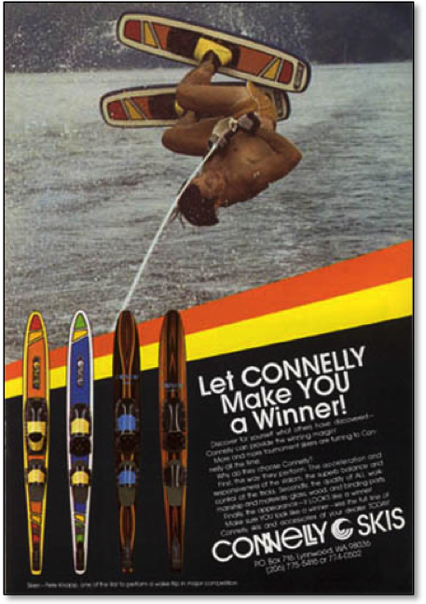
This ad of Pete Knapp inspired me to try the trick ski front flip off the wake. The Water Skier: Dec-Jan, 1978.

Mike’s response to my new tricks was to start doing helicopters on his slalom ski off other boat’s stray wakes. It wasn’t a new trick for him, he just dusted it off to show that he still had one up on me. I followed suit, and it was my turn to up the ante. I would try a helicopter dock start. The two foot tall dock at Mike’s shop was the perfect height. There was just enough time to complete the spin before hitting the water. It only took one set. I wrapped up as the boat idled out, and the initial tug from the boat pulled me off the dock and into the 360. The key was to idle out at a good clip. With that I got a snappy spin and stayed on top of the water after landing.
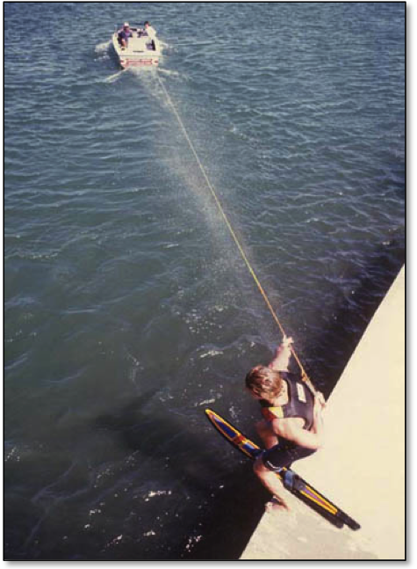
My fourth new move of the summer: a helicopter dock start on a slalom ski.

Now it was time to really razz Mike. I had an amazing summer of skiing. Four new hot dog tricks to call my own, plus a front flip on the trick skis. I knew that I had finally surpassed Mike. But Mike also knew that he was still the top dog. He kept his mouth shut all summer, and just went to school, carefully watching me learn each trick. He had casually asked me about the little things I did to make each new move.
Then it was his turn.
In one set Mike made all four of my new slalom ski tricks. It took me the entire summer! Mike’s “Just you wait, Tony” had arrived.
“I guess your uncle Mike has still got a thing or two to teach the whippersnapper,” he said after he completed his last trick. It was one of the greatest single sets I have witnessed.
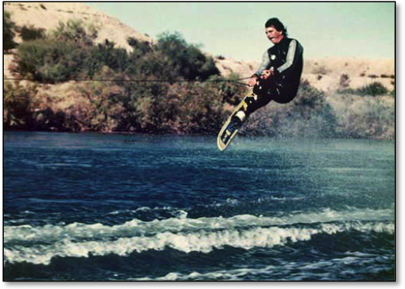
Mike was still top dog in the early 1980s.

***
Herbie Fletcher was yet another innovative waterman spending time on the River that summer. Herbie was already a surfing legend famous for charging hard at Pipeline, walking the nose on his longboard, and side-slipping in the tube. Herbie was also heavily involved in the surf industry as a retailer and manufacturer. One of his newest innovations was Astrodeck, the colorful non-skid that replaced wax on surfboards. Mike Mack, longtime surfer and water skier, was in the perfect position to help bring Astrodeck to water skiing. He hooked Herbie up with Murphy to promote Astrodeck as a great non-skid for water skis, especially for riders who used a rear toe strap instead of a boot binding. We all put it on our skis, and the ski industry followed suit. The days of black sandpaper or a piece of carpet were coming to an end.
Art Brewer, well-known surf photographer, came out to the River that summer to shoot promo shots for Astrodeck and to get a sequence of Mack’s Bodyslide. I was asked to perform my new hot dog moves. Being asked to ski for a big time photographer meant that I was good enough to get some free stuff. Art set me up with some wetsuits from O’Neill. Wearing the all-red full suit made me feel like a comic book superhero.
The shoot was thrilling, and going back to Brewer’s studio to review the hundreds of slides was a real treat. Mack’s Bodyslide got turned into a poster, Murphy got a full-page ad for Astrodeck, and I got my first picture in a magazine, flying over Mike in the two-man kneeboard act.
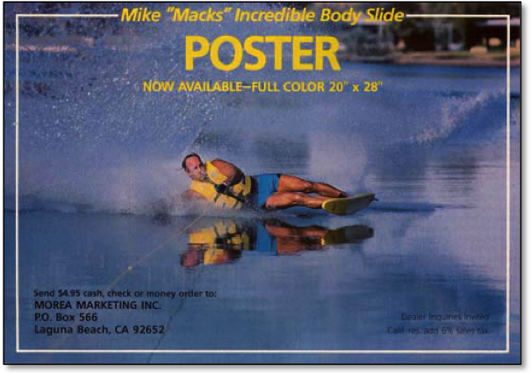
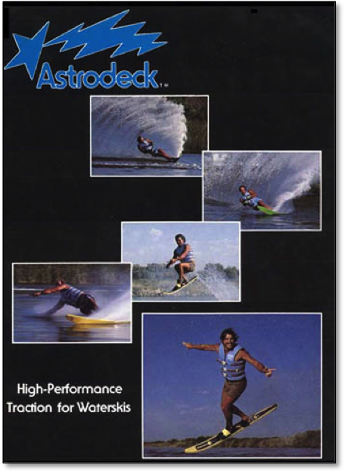
Surfing and skiing blended at the River for the development of Astrodeck.

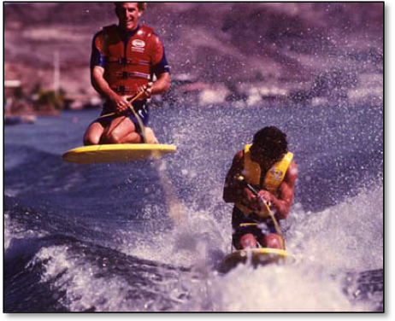
Uncle Mike trusted me enough to go over the top for my first magazine photo in 1982.

Check out Art Brewer’s Amazing photography here:
http://www.artbrewer.com/
This site also includes a great video of Art’s work in surfing.

The summer of 1982 was over, and I returned to a calmer life at Cal State University, Long Beach. My favorite college courses were “Drawing on the Right Side of the Brain” with Betty Edwards, and “Philosophy in Literature” where we read and discussed Dante’s “Inferno”, the “Book of Job”, and Goethe’s “Faust”. It was a far cry from being a River Rat. So to stay in touch, and advance my skiing, I took classes in gymnastics and springboard diving. It was all aimed at improving my aerial awareness for the slalom ski front flip.
1983 was going to be my third full summer on the River, but my heart was elsewhere. I wanted to be a show skier at a real show, just like my uncles had been. But now that I had experience and a bit of notoriety Mike said he needed me at the River for at least one more season. So I listened to my elder, and went out to the River.
Fortunes soon changed.
The Parker Strip flooded that summer and it was completely shut down to boat traffic. No boats meant no lessons, so I was free to become a professional show skier.
My memories of that time on the River are so special. The pleasure and the pain. I lost my virginity in Nick’s trailer on the hill. Then, in some sort of cosmic payback, uncle Nick gave me the job of putting creosote on the walls of his new shop, which was a converted trailer. He forgot to warn me the stuff burned your skin, and I did the job in a bathing suit and thongs. I splattered myself with the nasty stuff and got dozens of blisters that burned my skin for days.
I played guitar with Mack, snuck into the Sundance bar for the first time, and skied naked. But it wasn’t all just fun and games. Mike was a big supporter of the Arizona Special Olympics, and every year at the end of summer we all got together to donate a weekend of free instruction for the kids. Talk about a great feeling for everyone!
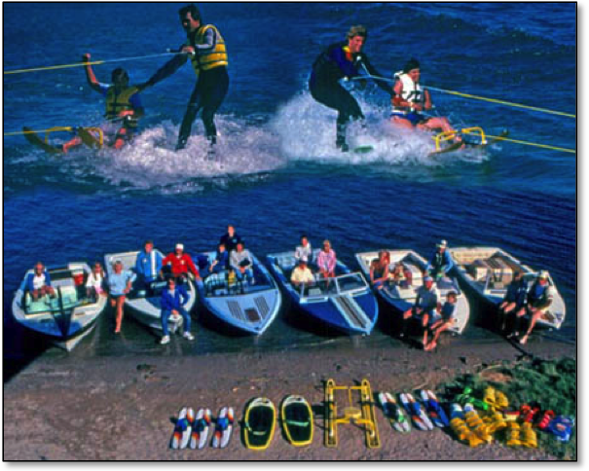
The Arizona Special Olympics were a community effort put on for many years by Murphy, Mack, and company.

My two full summers of residence at the River changed my life. I went from boy to man, and was ready to set out for new challenges.
After leaving the River I landed a job at the Magic Mountain Ski Show just north of Los Angeles. It took me a season to find my groove as a show skier, and I trained hard to improve. After mastering every act except long distance jumping, I went on to make my first slalom ski front flip. That flip was my big break, and lead directly to my first steady paycheck from HO Sports.
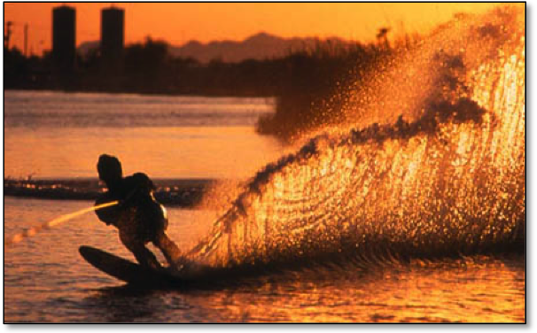
Sunset fell on my Golden Days on the River.

ISKI4HO
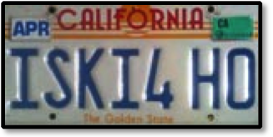

I was first with the slalom ski front flip, so Herb O’Brien sent me to Orlando for pictures with Tom King, the leading photographer for Water Ski magazine. The ski I rode was the Turbo, and I became the pro rider promoting it. It was a little wider in the body and tail than HO’s high-end slalom ski, but still turned on a dime. I loved the Turbo, right out of the box.
The photo shoot was at Mike Ferraro’s place. Ferraro was another HO team rider known for his ability on a trick ski and years as a coach of world-class skiers. His white cockatiel perched on the front windshield of his boat, even when we were at speed. Ferraro was a character, and made me feel relaxed right away. We were both hot doggers at heart.
Tom King was great to work with too. It was intimidating to finally meet the man who had taken just about every picture you ever saw in Water Ski magazine. He shot all the greats: Sammy and Camille Duvall, Carl Roberge, Deena Brush, Ron Scarpa, Mike Seipel: and now it was my turn! He was so laid back; you would never know he was this famous photographer. He knew his stuff and we got the goods.
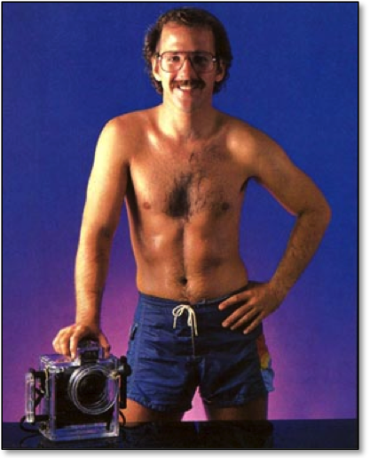
“The King of Skiing Photography”, 1985.
http://www.tomkingphotography.com/

My front flip first appeared as a two page “ETC.” sequence in Water Ski. Not only that, they promised more to come, and delivered. I got another two pages for the slalom ski tumbleturn and a series of instructional sequences.

Here’s a Typical “Hot Dog Tip” from 1985 (scroll down):
The Big Finish: Slalom Ski Backwards Landing

The slalom ski front flip also opened the door to a four-page feature in Powerboat magazine that also included my first cover shot. Trailer Boats and Hot Boat ran similar feature stories. In 1985 Trailer Boats called me “the pin up skier of the summer”, and I became an “overnight” success in water skiing.
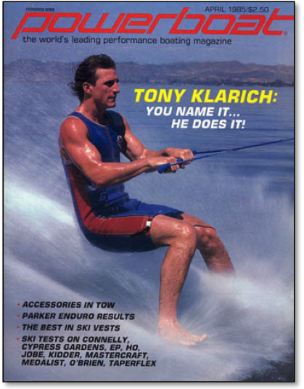
My first big ink was this cover shot in 1985.

Read the whole Powerboat feature story here (April, 1985):
Tony Klarich: You Name It - He Does It

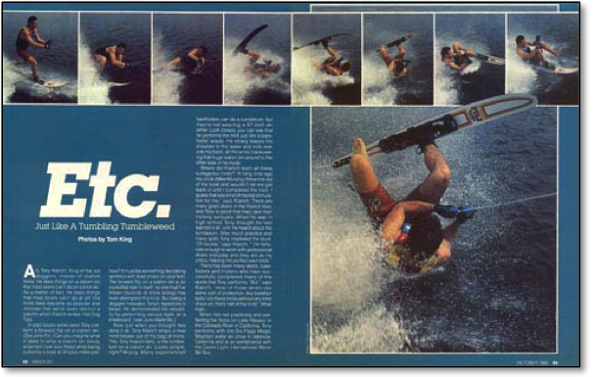
Taking a page from uncle Mike’s hot dogging handbook. 1985

I also landed my first TV commercial and joined the Screen Actors Guild. The spot was for Nabisco Better Cheddar crackers. My introduction to the world of Hollywood was a real eye opener. It took a production crew of about 40 people all day to shoot 12 seconds of a 30 second commercial. These guys had no idea about water skiing. By the time we got going in the afternoon the water was rough. They wanted me to do the flip without slowing the boat down. Not only was the water choppy, it was a little brisk. They left me out in it for 10-15 minutes between takes, without a wetsuit. It didn’t take long to get cold and tired.
It took everything I had to put on a good show, and they eventually got what they wanted. My fellow Magic Mountain show skier Tim Trella snapped a headshot for me later that night, and helped me to write a bio that I would need for future jobs. The Nabisco spot was Tim’s first big commercial too, and he went on to make it big time in Hollywood as a stunt man and stunt coordinator.
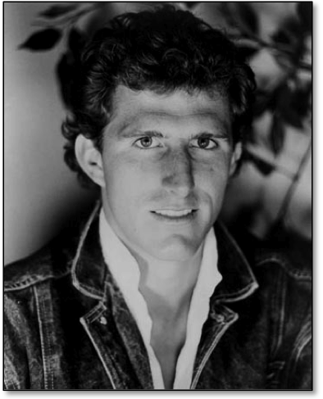
Breaking into Hollywood - my first head shot.

The first time I saw the Better Cheddars commercial was on Saturday Night Live. What a feeling to have it play during such a popular TV show. The pay wasn’t bad either, it was my best commercial payday ever at five figures. I got paid for the day of work, but the big money was in the residuals. That commercial ran hundreds of times over the next few months. I would have made much more, but cable TV was brand new, and the SAG contract for it maxed out at a very low flat rate.

See it here:
Better Cheddars Commercial

My skiing career was finally moving, but I had a secret. I was breaking skis on the front flip landings. They just weren’t ever expected to take that kind of abuse. Eddie Roberts was the man to the rescue. He was Herb’s long time go-to guy for skis, bindings, and just about everything else. Eddie made me some special Turbos with extra fiberglass and resin in the front third, and they worked like a charm. Eddie was my go-to guy too, and I called him whenever I needed anything. For years I tried to stump him with difficult spelling words, but he was amazingly accurate. Eddie was also in charge of the ski team, which in the early days was headlined by Deena Brush, Cory Pickos, Britt and Tawn Larsen, and me. What company!
HO started running full-page ads with me flipping on the Turbo. They were so popular that after the first year they were moved to the back cover for another season. Now that I was becoming known in water ski circles, I was sent on the road. It was exhibitions and on-water clinics in the summertime, and boat shows in the winter. I got a big raise. It was enough to live on. The schedule was demanding, averaging about 35-40 weekends a year.
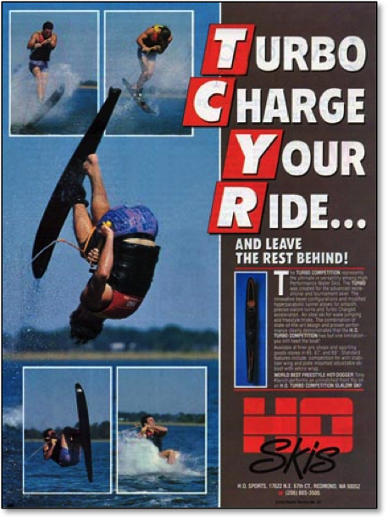
I loved the HO Turbo!

A typical boat show weekend started with a plane out of LAX on Friday. In those days you could show up at the airport 20-30 minutes before the flight, check bags, and still make the flight. I’d arrive at the boat show city in the early evening and get picked up by the local HO rep. Joe Sassenrath, Scott Simms, Eddie Beverly, Bobby Reich, and Rick Skinner all became familiar faces on the road. The next stop was a convention center or hall; just in time for the last few hours of the Friday night rush.
Once inside a building, all the shows looked pretty much the same: boats, equipment, bright lights, and the excited din of people shopping. I helped the dealers sell their product and talked to the public about skiing in general.
When the boat show shut down at 10:00 p.m. on Friday and Saturday night, we usually headed out for dinner with the dealer. Good food and few rounds of drinks usually ensued; all courtesy of HO. Every time I walked out of an establishment I made it a habit to give an audible “Thanks Herb”, even though he was usually miles away.
After a late night and not enough sleep it was back to the show, usually around noon. I squirted down a lot of feet to help people try on bindings, and listened to their war stories about all their skiing exploits. The shows ended Sunday at 5:00 or 6:00, and I sometimes left a bit early to catch a flight back to Los Angeles.
It was the reps and dealers that made the shows fun to work. Tommy Phillips, owner of Tommy’s Slalom Shop in Denver, was always a character. He constantly peppered his conversations with “no blocking, up the middle” and “a carton of Camels”. His promotions were always top notch, and he was always thinking up new ways to bring more people into skiing. Tommy was always at the forefront of whatever was next, including kneeboarding, wakeboarding, and hydrofoiling. A trip to Tommy’s was sure to be a great weekend. Bill Porter of Performance Ski & Surf in Orlando was another legendary dealer. He sponsored just about every top skier, including me, with t-shirts, hats, board bags and all the cool stuff.
Both men had a true passion for the sport, and did whatever it took to keep things moving to the next level.
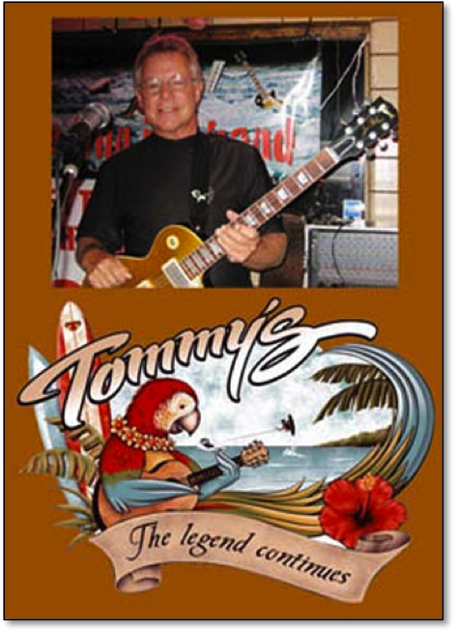
Tommy Phillips, Denver Superdealer.

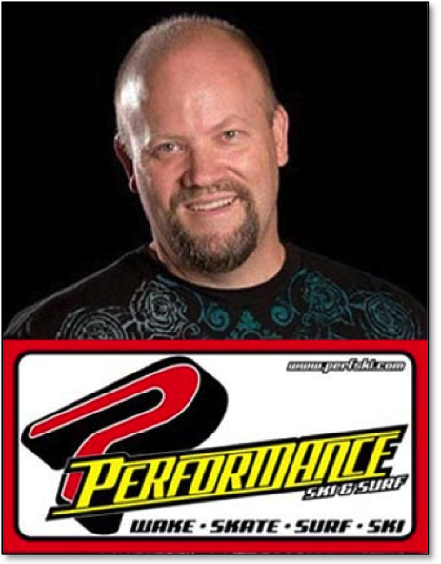
Bill Porter, Orlando Superdealer.

In the summers I always looked forward to performing on the Water Ski Pro Tour. We had typical crowds of 2000-5000 for the weekend events, and they were pumped up to see the best water skiers in the world. Riders like Sammy Duvall, Bob LaPoint, Andy Mapple, Deena Brush, and Camille Duvall were always crowd favorites in slalom and jumping. I was one of the exhibition acts, which could include anything from barefooting and hang gliding to kneeboarding and trick skiing. C.W. Lowe was the ever-present dock starter, while Jack Walker or Skip Gilkerson pulled me dozens of times for hot dog and kneeboard runs. It was a bit tricky to dodge the jump ramp and all the buoys, but my years of show skiing on a tiny lake helped immensely.
In my early days on the Tour, skiing was still pretty centralized. There was only one Pro Tour, and all of the various disciplines of skiing were represented throughout the year. The Professional Tour was new and fresh. It was a rush to be skiing at an event with the same skiers I idolized.
***
In 1986 HO Sports was planning to film their first big promotional video, and our Colorado River crew was called to Florida to add some hot dogging flair to the traditional skiing. I went along with uncle Mike and Mack. On the plane Mike had one of the funniest one-liners I have ever heard. It was back when you still got peanuts, and as the flight attendant made her way through the aisles Mike chatted her up. She seemed friendly enough, so when Mike was done with his peanuts he lifted up the bag and he innocently said, “here, have my nut sack.” She just smiled indulgently and took the bag.
After we landed in Orlando and made it to our location, the film crew was a little perplexed. “Why did you bring these guys all the way from California, when we have all the best skiers right here in Florida?” they wanted to know. They soon found out, and were duly impressed with the unique skiing and professionalism we brought from the West Coast.
When you have a photo or video shoot, it’s always best to have a group of guys that have worked together. Our team of three was in perfect synch and we hit all the spots the film crew requested. We did moves that they had never seen. It was exciting to be on location with fellow HO Team Riders Deena Brush, Cory Pickos, and the Larson twins.
In addition to the 15-minute promo video we also shot a 30-second commercial. It included a montage of our best moves, which culminated with uncle Mike making a slalom turn to spray a wall of water on Deena. Cory was hanging out on the beach watching the whole thing. Deena was drenched, but had a big smile.
“Hey Deena, high output skiing, huh?” said Cory.
“Yeah Cory, HO” she replied.
What a great time!

See them here:
HO Commercial
HO Team Promo Video
***
Somehow, in between show skiing part-time, going to college, and traveling for HO, I landed a job as a longshoreman in the Port of Los Angeles. Stevedoring was what my dad did all his life, and that helped me to get into the union. We still handled a fair amount of cargo by hand in the 1980s. My first job was throwing endless boxes of bananas onto a conveyor belt going off the ship. Every once in a while a green snake or giant spider crawled out of one of the boxes. I also drove a forklift, lashed containers on board the ship, and did laps in a semi-truck to deliver containers in the yard. The schedule was perfect for my skiing. I got to pick and choose the days I wanted to work.
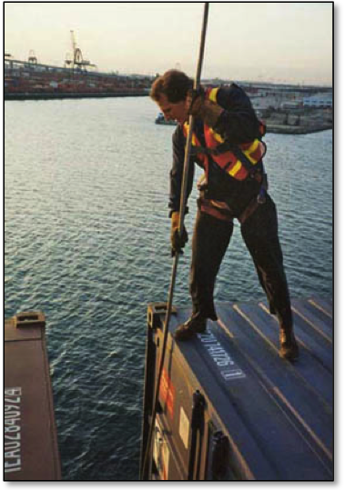
ILWU Local 13, early evening unlocking on 5-high containers.

Our family still found time to water ski at the Marine Stadium. One day Mike and I decided to have a fun contest. No one had ever done a backwards beach start on a slalom ski, so we were going to see who could do it in the least number of tries. Whenever something like this came up, I was always the one who had to go first. Mike always went last so he could “go to school” on the first guy. When it was all said and done, we each made it on our 11th try. Mike still had plenty of gas left in the tank.
I was still making trips to the River, kind of like a salmon returning to its birthplace. One such trip was with a bunch of high school buddies. Drink, drank, drunk was the main objective. Some ancient alcoholic woman at the end of the beach kept hitting me on. It was disturbing.
“Hey Tony, the old lady wants to see you in her tent,” became a favorite line of the weekend.
In the midst of it all some guy I didn’t know pulled up with a tournament boat and was looking for me. He asked if I would like a ski ride. Are you kidding? We had been messing around behind a rented Jet Ski with unsatisfactory results. I took a hot dog slalom ride, showing off for my bros. The old lady liked it too. The guy, Greg Nix, became my new River Rat partner. After the show he took me upriver to his parents’ trailer on the water. The air conditioning sure beat hot tents on the beach. In the ensuing years Nix and I made dozens of trips to this little Shangri La. Over the years we devised various methods to show off and pick up chicks. We had the backwards bit down to a science.
“Hey Tony, start backwards,” he would shout across a crowded beach.
I stood in knee deep in the water, ready to do a regular shore start on my slalom ski.
“What?” I would shout back.
His reply, “start BACKWARDS!” was even louder. By now the whole beach would be glued to the guy starting backwards off the beach, and away I went to the sound of hoots and hollers.
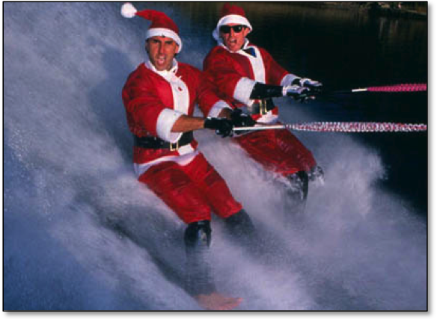
HO! HO! HO! Naughty or Nice?

Another one of our smooth operations was to hook up with the ladies. We would cruise the beaches in Nix’s tournament ski boat, looking out for a potential pair of beauties. When we found our targets Nix laid out the famous line, ”We need an observer to ski, would ONE of you mind riding along?”
And then the inevitable response, ”Can my friend come too?”
Why yes, of course!
Nix was a pretty good skier, and he would always ride first. The girls were impressed. Then it was my turn. Nix usually pretended to be the instructor. I was just learning to ski or kneeboard. After floundering around for a while, I would bust a big move. The jig was up. Everyone had great fun with that one!
Now, just to prove we were nice guys, we wouldn’t hit on our prospects too hard, we’d just drop them off and plan to meet them at the Sundance bar that night. I mean, all we needed was an observer, right? We would repeat this performance three or four times in a day with different sets of girls, and our evening was set.
On one such performance the outcome was tragic. It was Labor Day on the River, and we had found a couple of girls to ride. I did a back dock start on my slalom ski and we started upriver. The River was crowded and I was on the lookout for other boats. On our right a low profile jet boat pulled away from the gas dock. As an experienced skier my first thought was to keep a watchful eye on them, because it was one of those crazy weekends, and people do stupid things. As soon as that thought popped into my mind, the driver made a hard left turn and hit the gas. I believed that their boat would come between our boat and me so I started to cut out to the right to get clear. The other driver accelerated so fast that they actually got directly in the path of our oncoming boat. Their boat had four or five people on board, and when they turned, it made a perfect ramp for our tournament boat, which rode directly over the top of their passenger compartment. I can still hear the sick sound of that unbelievable meeting. Our boat flew up and over, and Nix was ejected out of the driver’s seat. He flew through the air like a rag doll and landed in front of our boat. I thought he was going to get run over too. The next thing I saw was a guy with his right arm hanging on at the shoulder by a thin piece of meat. Blood spurted with each beat of his heart, and he screamed in agony. I was in instant shock and my first reaction was to swim to shore.
In just minutes a helicopter landed to take the injured man away. We found out later that he died. Fun in the sun one minute, dead the next. Life is so fragile.
Even though it was a big holiday weekend, neither one of us had been drinking. It was stupid to ski on such a crazy day, but the lure of showing off for big crowds and the ignorance of youth guided our actions.
In the days that followed we learned the driver of the other boat had been drinking. She was badly injured too, sliced by the skegs on the bottom of our boat. For years I was plagued by the accident, and a sense of what we could have done to change things. I had nightmares, and jittery moments while skiing whenever another boat got too close. As the years passed so did the immediacy of that day. I came to grips with what happened. It was an accident: a series of unfortunate events leading up to a deadly conclusion. The real lesson I learned was that party weekends with drinking and boating don’t mix, and ever since then I avoided riding on crowded party weekends.

HOT DOGGING HIGH
In 1988 hot dogging was riding a wave of popularity, and Water Ski magazine wanted me as the lone rider for an instructional book and video. The projects were done on short notice, and I spent the next month organizing tricks and writing instructional copy. To save time the book and video were produced at the same time. Terry Dorner from World Publications, the parent company of Water Ski, was assigned to the project as the publisher, photographer, organizer, and my day-to-day contact. Terry’s jack-of-all-trades background as a skier, writer, and company man was hugely helpful in the successful completion of the project. As an added bonus we had a great time working together. We enjoyed serious conversations about things extending far beyond a back scratcher.
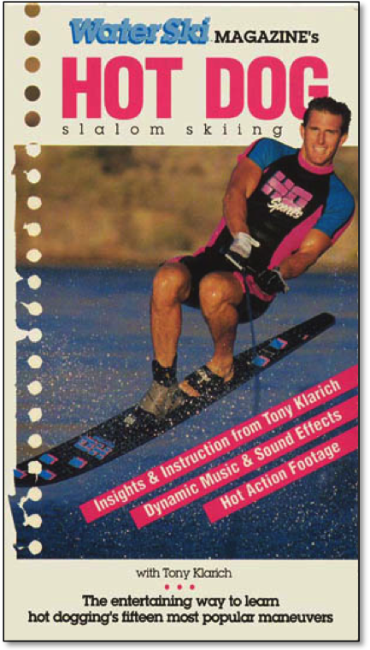
Hot Dogging was riding a wave of popularity in the late 1980s.

The only negative result of my book and video was personal: I never received any royalties. I did, however, get a huge amount of press. Ads for the book and video ran in Water Ski for years. In September 1988 I finally appeared on the cover of Water Ski. The cover and the feature story inside was part of their plan to promote the Hot Dogging book and video. My value to HO and other sponsors went up. I picked up sponsorships from Ray-Ban and Body Glove. There were more commercials, videos, and TV shoots. I was occasionally recognized at airports; but then again, a guy lugging around 80 pounds of ski equipment plastered with HO Skis was a dead giveaway. My peak of public fame came at an Anaheim Angels (as they were known in those days) baseball game in the late 1980s.
“Aren’t you Tony Klarich?” someone asked in a neighboring row.
I was with a bunch of friends, and it felt a little strange to be spotted outside of the skiing realm. It was the one and only time besides at an airport or ski event that someone approached me in public. The guy who recognized me wanted to talk about skiing, but I was with my buddies to see a baseball game. That incident was a revelation. There is a price for fame, and the more famous you become, the more you become public property.
I was fortunate to be just famous enough. I could still walk the streets in anonymity, but it was fun to be at a boat show or ski event and play the part-time star.
Water skiing was fulfilling all of my childhood dreams. I traveled the world, and got paid good money to do my favorite thing for tens of thousands of people. Along the way I signed posters, got free food, and had an in with the ladies. What else could a young guy want?

REALITY CHECK
While I was completely satisfied with my skiing career, I was just as unsatisfied working as a longshoreman. Skiing was amazing, but I was realistic. The high wouldn’t last forever, and I would eventually be working full time on the docks.
Did I really want to mindlessly move containers around for the rest of my life? My answer was no.
I wanted to do something positive with my life, and decided to become a chiropractor. My choice was inspired by Dr. Emilio Alvarado, who fixed my hurt back after years of discomfort from my barefoot fall on the River. Emilio was an extreme athlete who did it all. He was a skydiver, helicopter instructor, and avid skier who had a house on the water in Lake Elsinore, CA. He loved his job as a chiropractor, and was good at it. He seemed to have it all, and I wanted it too. Chiropractors made a difference by helping people.
So I went back to community college for courses in biology and chemistry to see if I was ready to take the back cracking plunge. School was tough, but I thrived on the challenge of using my brain again. It was all systems go as I enrolled myself at Cleveland Chiropractic College in Los Angeles. It was the most intense three years of my life. From dissecting cadavers, to all night cram sessions, and a year of internship. I was taking nearly 30 units per semester, working 800 hours a year on the docks, and hitting the road full-time as a water skier.
Airports, planes, and hotel rooms made a great place to crack the books. I dropped out of the late night dinners and club scenes to concentrate on my studies. But my next trip was a study in something even more important.
I had never been to Boise, Idaho, but my man at HO, Eddie Roberts, had me raring to go. He was playing matchmaker between me and a pretty blonde who would be working the HO booth at the boat show.
I arrived at the Boise Fairgrounds building and walked across the cement floor toward the Water Ski Pro Shop booth. The pretty blonde was standing in front of the booth watching my immanent approach. Even though we had never met we locked eyes from afar. Everything went into slow motion, just like a movie. I walked straight up to her without any preconceived plan or pickup lines.
We had never been introduced, but I knew she was the one. I grabbed her hand and held on tight while I gazed intensely into her beautiful blue eyes.
“Is there a spark?” I asked.
She thought a moment while she worked her hand free of my firm grip.
“I’m not sure yet,” was her reply.
Shonna Johns was convinced that I was some big shot skier who had a girl in every port. Sure, I liked girls like any other guy, but it really wasn’t like that. Shonna was different right from the start.
We worked side by side in Tim and Bernie Mueller’s booth that weekend, and went out to dinner with everyone from the booth. Boise wasn’t the cow town I expected. We climbed a frozen chain in front of a club. Eddie bribed Shonna with a pair of ski gloves, and she mooned me from the rear window of the car ahead of us. We did donuts in a snow-filled parking lot. This city was fun, and I really liked this girl!
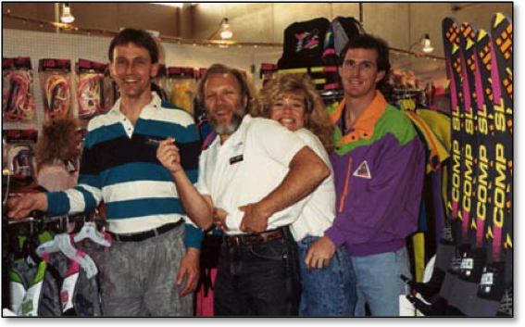
I met my wife to be, Shonna Johns, at a boat show in Boise.
(L to R) Tim Mueller (Water Ski Pro Shop), Eddie Roberts (HO Sports Competition Director & Matchmaker), Shonna, and me.

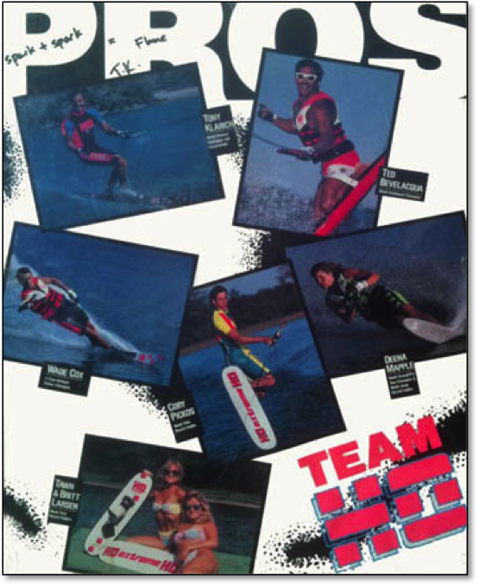
At the end of the weekend I signed a poster to Shonna with “spark + spark = Flame”. We planned to meet again. Team HO, 1989: Deena Mapple, Cory Pickos, Tawn and Britt Larsen, Wade Cox, Ted Bevelacqua, and Tony Klarich.

As I drove to work on the following Monday, the revelation hit me like a ton of bricks: this is the girl I’m going to marry.
A long distance romance blossomed. She came to L.A. and I took her to In-N-Out burgers and skiing at the Marine Stadium. I flew to Boise and chased her down the hill snow skiing. We met up in cities across the nation were I was doing ski events. It was literally a whirlwind romance. We created the “skoch scale” that measured our growing love. When it got to 25 it was time to get married. Each of our rendezvous added more points.
We finally hit 25 on the skoch scale, and decided to tie the knot after I graduated from Chiropractic College. As Shonna planned the wedding in Boise a crazy idea formed in her head. We would take a skiing picture for our wedding announcement. The problem was it was the middle of winter in Boise.
To get Shonna’s picture we drove up to Lucky Peak Reservoir through snow-covered mountains. Tim, Bernie, and Annie Muellers from the Water Ski Pro Shop were our support crew. Tim put chains on the car to launch the boat. Something about that did not seem right for a California boy. As he backed the boat down the long incline we began to slide toward the lake. My longtime fear of launching a car seemed near at hand! Tim remained cool as a cucumber. When the rear wheels of his Suburban hit the water’s edge the car and boat stopped sliding. Whew! That was scary.
Even in drysuits the conditions were unbearably cold. The wind chill was factor was 24 below! There was ice around the edges of the lake, and a blanket of thick snow covered the ground. My plan was to try and keep us both as dry as possible for the photo. I shimmied out on the boom with a pair of combo skis, and practiced a couple of swing outs on the five-foot extension. So far so good except the 6-12 inch wind chop.
I coaxed Shonna out onto the boom and into my arms. Her white veil kept blowing over her face. I finally had her in my arms and let go of the boom to swing out. I only got one hand on the handle and I lost control in the rough water. We did a wheelie, then we both went down with a splat into the frigid waters. Brrrrrr!
Shonna’s hair was frozen stiff for our next attempt. It took her even longer to work up the nerve to come out onto the boom. I really didn’t blame her after I told her how easy this would be. “Trust me, its’ no big deal,” I told my future wife. But I knew we had to make it on the second attempt. I was already too cold and losing strength.
We let go and our future hung in the balance for several seconds. We teetered back and forth as I struggled to get both hands on the handle. The rough water grabbed at my skis and the outcome was in question.
I bent over one last time and got the handle. The look on our faces went from fear to happiness. We made it! We smiled for the camera and Shonna got her crazy picture.
I knew there was something wrong with snow chains and water skiing!
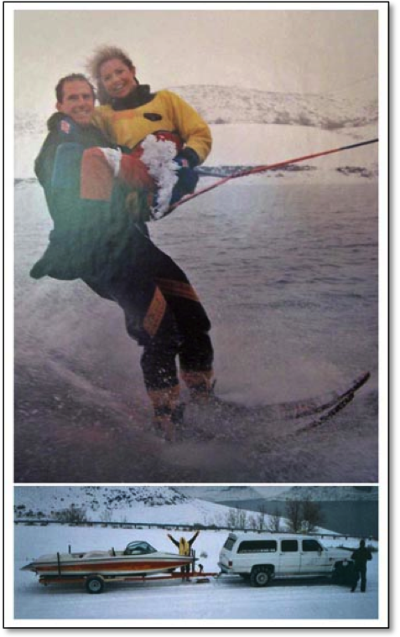
Shonna’s wintery wedding picture; Lucky Peak, ID.

See the video here:
“Snow Skiing” on Lucky Peak

63-INCHES OF VERTICAL AIR
Hot dogging was riding a high, and people around the world wanted to learn how to do it. Skiers were chasing the feeling of freedom and excitement on the water. One of the limiting factors was that hot dogging was just too hard for the average skier on a regular slalom ski. So to make things easier HO came out with a ski specifically designed for hot dogging.
Mike Mack was always tinkering in his ski shop and school, which he took over from Mike Murphy. Mack took a Magnum, HO’s ski for the big boys, and cut off 12 inches from the tail. The new ski was much shorter than a regular slalom ski, and a lot wider through the body and tail. Mack’s ski worked great for teaching beginners, and doubled as his new ride for hot dogging. People on the River loved the new design, and so did HO.
Mack’s design became the Vertical Air, and I became the front man. The stubby ski was 63 inches long and 7½ inches wide. The Vertical Air allowed hot doggers to ride a few mph slower, and it had great pop off the wake for jumps and tricks. The width made it easier to do surface turns, and gave it a much more stable platform for riding backwards. The release of the ski garnered another round of press, promotion, and full pages ads. I was along for the ride once again.
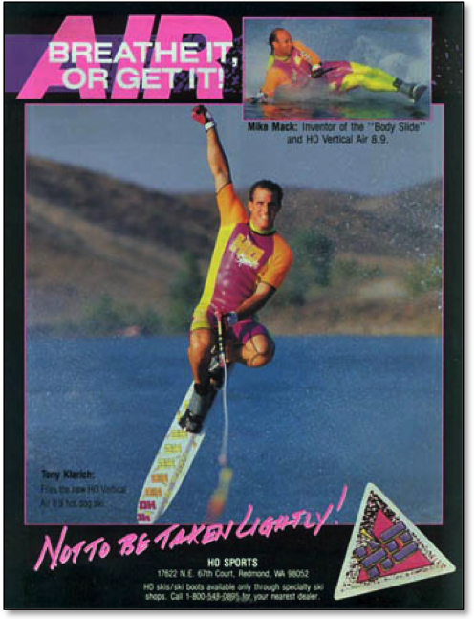
Mike Mack created the Vertical Air and I was the front man.

Connelly Skis got on board with their version of a hot dog ski called the F44 Craze. The battle between the two skis was highlighted by a four-stop competition on the Water Ski Pro Tour between myself, Tony “the King” Klarich, and Dave “the Dog” Reinhart. Dave was in the midst of winning eight straight overall Pro Tour titles in freestyle jumping. Not eight single event wins; rather, eight overall Pro Tour titles that recognized Dave as top dog for almost a decade. He also competed in the new Pro Tour wakeboarding competition, and was often a finalist against the “real” wakeboarders. Like myself, Dave was an all around skier at heart, and was viewed as an outsider by the wakeboarding community. He didn’t care. No baggy shorts for this future Hall of Famer.
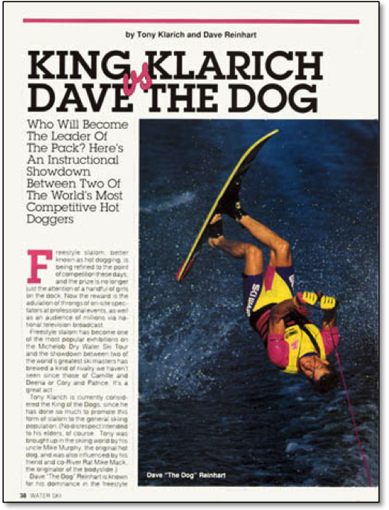
“Dave the Dog” Reinhart: One of the World’s best all around skiers, and a great guy!

I was glad to finally have a chance to compete against Dave on the Pro Tour, even though it was just another event for him. He rode the F44 Craze because Connelly needed someone to promote the ski, and Dave was the logical choice. He dabbled in hot dogging. I had been doing it all my life, and had a stable of tricks honed over years of hardcore riding. Even so, Dave was a real challenge, and turned out to be one of the best hot doggers I’ve ever had the pleasure to ski with. In the end I won all four events and the “Tour Title”. I was at the top of my hot dogging ability, and for Dave hot dogging was number three or four on his skiing list for a few summers.

HOTDOGGER’S HANGOUT
With hot dogging in full bloom, the new hot spot was the Long Beach Marine Stadium. For several years a hardcore group of riders created the “Hotdogger’s Hangout”. Roger Crocker was the lead local: he lived beachfront at center stage. All he had to do was look out his window to check in on the action.
Roger did the front flip on a slalom ski too, but his claim to fame was sliding. He spent a lot of time barefooting, so that heavily influenced his slalom skiing.
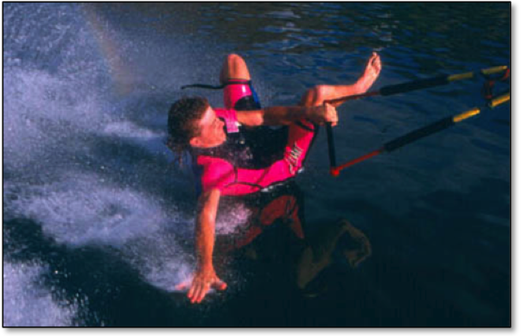
Roger Crocker transferred his barefooting skills to Hot Dogging, and visa-versa.

Whenever Roger strapped on a ski he pulled tumbleturn after tumbleturn behind the boat without standing up. He took Mike Mack’s Bodyslide to new levels, adding his own style and flair. He laid down on the job with his “Sleeper”: one arm behind his head and eyes closed as he slid on his side and shoulder. He whipped off several other variations, the best coming around the closed end turn of the Stadium we called “Cadillac Corner”. Coming up with new moves was always easier when guys who are on the same path push each other in a friendly way. One night hanging out in Roger’s trailer next to his mom Betty Crocker’s house, we brainstormed about skiing. Earlier that day I had done a body slide, and my ski got too far behind me. Instead of letting go I told him how I just rolled onto my back. Roger’s face immediately lit up. He knew instantly that the bodyslide tumbleturn would be a trick to call his own. The next time out he ripped off a dozen as if he had been doing them all his life. Sometimes the hardest part of doing a trick that no one has done is just to imagine it.
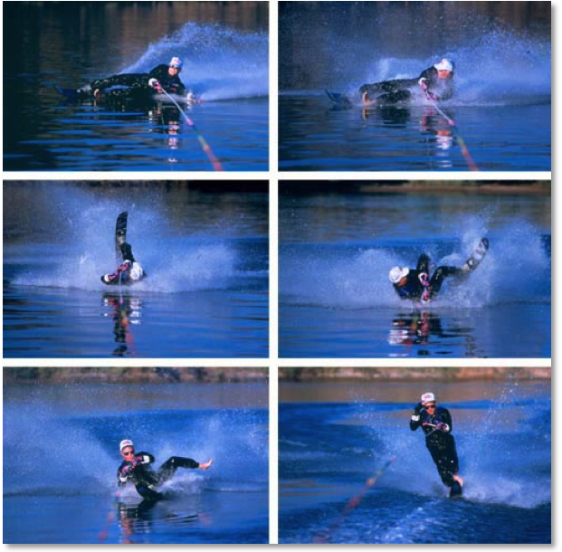
Roger Crocker was the master of slides on a slalom ski. His bodyslide tumbleturn.

Ronny Gayman was another hot rider back in the day. He was getting good enough to get a ski sponsorship, and I agreed to introduce him around at the L.A. Boat Show. He came dressed to the nines in punk gear, complete with knee-high black boots, studded leather and spiked hair. His business card byline read “Buoy Chasers Nightmare”. I’ve got to give it to Ron for being true to himself, but he was a little ahead of his time as far as his looks and attitude. He did get picked up by Connelly Skis and for a few years was determined to be a great hot dogger. He made flips and rolls on his ski, but his craziest move was the “high wire”. He pulled on the line so hard it would create enough slack so that he could just ski right over it. As the line came tight he would get a huge jerk. I did this move a few times, but it was too nerve wracking to keep doing. If you didn’t get it right the line would come tight as it was under your ski.
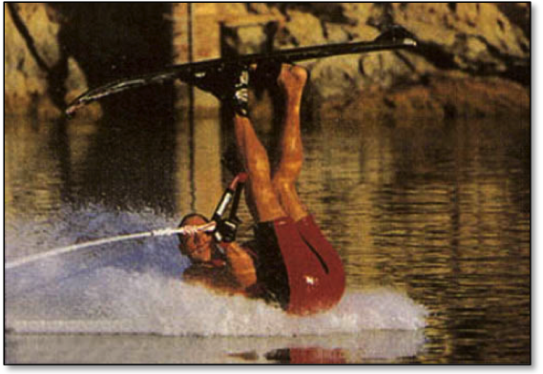
Ron Gayman’s own creation: The Frock slide in 1995.

See The Full Page Article from Ski Boats Magazine Here:
Frock ‘n Roll with Ron Gayman

Doug Pearce was another one of our “Stage Red” crew. I met Doug doing shows in the L.A. River near the Queen Mary in Long Beach. He ripped hard on his slalom, combining high-speed traditional turns with high-speed tricks. His wake-to-wake 180 behind the boat at 33 mph was just plain sick. But Doug’s claim to fame was the disc, ladder, and dog. He had a four-foot diameter wood and fiberglass disc topped with indoor-outdoor carpeting. He did a deepwater start with “Maude the Wonder Dog” between his legs, and the five-foot ladder hooked on one arm. Maude waited patiently as Doug set the ladder on the disc. When he got it into position Maude climbed the steps and took her spot on the paint step. Doug then carefully climbed to the top step and wowed the crowd. If that wasn’t enough Doug next performed series of 360-degree turns. The crowd ate it up. Every skier in those shows got upstaged by a dog! The humans flip and spin, but the dogs were always the stars.
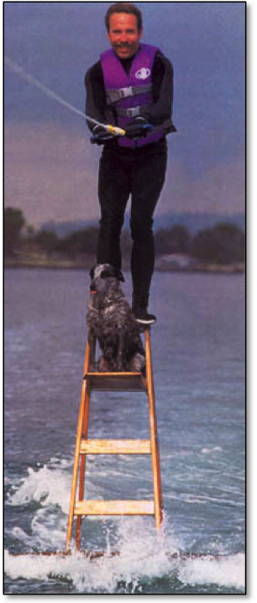
Doug, disc, ladder, and dog: A hard act to follow!

Our “Stage Red” crew expanded what was possible on a slalom ski. For many of us who were there it was a fine example of the “good old days”.
The hot dogging movement in water skiing was indicative of what skiers were looking for. It was something new and exciting that gave freedom of expression on the water. We didn’t have the rigid rules of competitions. It was about having fun, showing off, and finding new ways to ride. Many people who yearned for that feeling tried hot dogging, but it was just too hard. Riders needed an easier way to perform all the flips, spins, and big airs that were so popular on a ski.
If hot dogging planted the seeds of a new way to ride, then kneeboarding was the first spring bloom. The fun of flips and spins for everyone found much wider participation in kneeboarding. It was easy to do a surface 360 on the first day out. No way on a slalom ski. Getting inverted was way more accessible to the average rider on a kneeboard than a slalom ski. I know only a handful of riders who can flip a slalom ski, but I know scores who can flip a kneeboard.
But even kneeboarding had its drawbacks. The most obvious was the kneeling position itself. Many people found that position uncomfortable, especially when it came to going big and landing hard. Kneeling also took away the ability to spring off the wake with your legs.
It was the next sport, wakeboarding, that combined the feeling of hot dogging with the easy to ride accessibility of kneeboarding. Wakeboarding had many other benefits too. The upright position was much more comfortable and allowed riders to use their legs for jumping and landing. Wakeboarding was closely allied with crossover board sports like surfing and skateboarding. It became the first lifestyle sport in water skiing, and was a huge boon to the industry. But the requirement to maintain the cool image of wakeboarding also drove the sport to distance itself from its roots. Wakeboarding didn’t want to have anything to do with water skiing. Much of the scene was about what you rode, how you dressed, and how you acted.
It was personally frustrating.
As a hot dogger, I never felt completely accepted by traditional skiers. I was just the exhibition act in between the “real” skiing. When wakeboarding came along I thought, great, finally some riders who knew how I felt behind the boat. I related to those guys. The ironic twist was my rejection by the wakeboarding syndicate for being a skier!
Shouldn’t it be more about how you ride than what you ride?
***
Hot dogging had its fifteen minutes of fame, but its popularity was taken over first by kneeboarding and then later by wakeboarding. People wanted to learn how to do a backside roll on a wakeboard, not a backwards landing on a ski. HO and Connelly discontinued their hot dog specific skis.
The Vertical Air was fun, but I was glad to be back on a regular 67-inch slalom ski. There was something about the thrill of high-speed tricks that got my blood pumping. Plus, I didn’t have to sacrifice the carving ability to do tricks.
In the following years I focused my skiing efforts on whatever was the next greatest thing in the industry, and was fortunate enough to have been in on the ground level of kneeboarding, wakeboarding, and hydrofoiling. Starting in 2005 I went outside the box completely by making a hobby of riding things not made for skiing. I rode over 60 things including a car hood, guitar, and ironing board. But through it all I have always come back to my first love: the joy of hot dogging on a slalom ski.

OUT TO PASTURE WITH A STABLE OF TRICKS
In the mid 1990s I heard that legendary barefooter Brett Wing was doing a tick-tock-tick landing on a slalom ski. That’s front to back, back to front, and front to back before sinking, all after letting go of the rope. If he could do three 180 turns, I would try four. I had a name even before making it: “Quatro de Tocko”. But first I had to learn Brett’s move. The tick-tock-tick wasn’t so bad. It just required a bit more speed on the set up. The “Quatro” was more about balls than skill. I initiated the first turn at over 40 mph and hoped that I didn’t catch an edge on the first or second turn. The fact that I did catch a few edges did not deter me from making the move and claiming it as my own.

See Brett’s amazing video montage here:
Best of Brett Wing from the 1980s

I also found fertile ground with variations of the Whip Tick out wide. The idea for the Overhead tick tock came while I was taking a slalom set in the course. After I made a pass of all six buoys at top speed, it was time to stop the boat and shorten the line. I usually did a tick tock landing, and it became a natural movement to whip the rope over my head as I sank in the water. Another new trick was born.
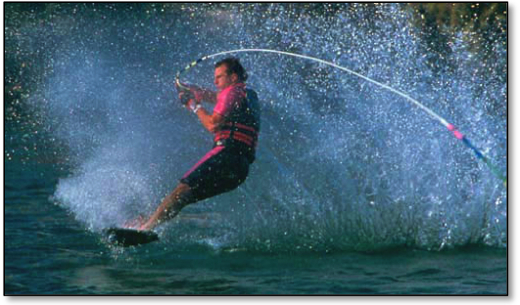
The Overhead tick-tock was conceived on the slalom course.

My Whip Tick was getting so easy that I started tweaking it out; staying backwards for a while, then sliding to the front. I had so much time in the sweet spot that I thought it was possible to do a double Whip Tick. I made the double on the first try, no problem, and on a good day was even able to turn it into a triple.
The one-foot back barefoot I had learned in show skiing inspired my favorite variation of the Whip Tick. I was already doing long slides while backwards, so why not lift my back foot during those three seconds. Getting into the one foot back position was the easy part, it was the return to the front that was tricky. After a few unsuccessful attempts of trying to get my foot back in the binding before turning, I just kept it out while making a quick hop to turn. Then I crouched down and dragged my free foot in the water like a rudder for better balance. I called that one the “Tick Tock Toe-knee”.
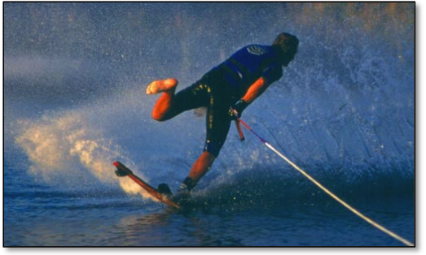
Tick Tock Toe-knee: my last big move in hot dogging.

While my hot dogging continued to improve for years after the popularity of the sport had peaked, there comes a time in every athlete’s life when the inevitable decline sets in. I worked hard to maintain peak athletic performance through the years, participated in strength training, aerobic exercise, stretching, and ate sensibly. But even with all this there was a slow, progressive loss in ability.
I celebrated my 40th birthday in part by retiring the front flip. It was an intense feeling to land that last one, having made a conscious decision to stop doing the move that brought me so much in skiing.

Hot Dog slalom skiing for the MasterCraft 40-40-400. Video including a backwards beach start, Tick-Tock-Toe-knee, and my last front flip here:
MasterCraft 40-40-400. Ride 23 of 41, Retiring the Front Flip

Could I do one today at age 46? Probably, with training, but as each year passes the possibility of injury gets higher and higher, even with perfect form. It was a brutal trick with a very hard landing and an extreme jerk of the handle. There was nothing left to prove.
That doesn’t mean that I will never learn a new trick on a slalom ski or something else. In fact I have thrived on riding things like the disc and ladder, car tire, guitar, and ice chest. It’s a lot easier to break new ground on these with less risk of injury.
For the past few years I have been somewhat of a fair weather skier, unless the riding was for the occasional job. When the weather is nice I still enjoy riding my slalom ski, Sky Ski, kneeboard or various odd objects. I ride for fun. Gone is the pressure to constantly improve or learn a new trick. That’s been a relief both mentally and physically. I try to keep a solid base to work from for the warm months, but my real training kicks in when it’s time to get ready for another event. In the 2000s that was preparing for an annual extreme ski and stunt show in Moscow, Russia. Now I think about the next big thing on my horizon: the “50-50”. I plan to celebrate a half-century of living by riding on 50 different things in one day. All the “regular” rides plus a suitcase, snow skis, and maybe even the kitchen sink! I’m looking for a marlin if you know somebody. Now that’s something to keep me busy for the next few years!

AFTERWARD
I hope you enjoyed my trip down memory lane. During those years everything sped by in a whirlwind of excitement. It was more than enough to just experience the wild ride. Today I’ve had time for reflection. All the research, interviews, and page-by-page examination of hundreds of ski magazines helped bring me to a new understanding of those exciting times. What emerged is much more than a step-by-step recounting of how things happened. Now I have come to a much deeper understanding of why they happened, and how hot dogging fit into the bigger picture of the explosion of watersports in the 1980s and 1990s.
If you have any comments, suggestions, or new information, I would love to hear from you. Please contact me though my website:
http://www.TonyKlarich.com

PHOTO & VIDEO CREDITS

ABOUT THE AUTHOR / PROLOGUE
Tony and Shonna Klarich. The Joker and Santa’s Helper. 1988. Photo: Rick Doyle.
Hyperlite Team. Dean Lavelle, Shaun Murray, Gerry Nunn, and Tony Klarich. 1997 World Champions. Wakeboarding; Fall, 1996. Photos: Doug Dukane, Tom King, and K/ Waddell.

A TURNING POINT - THE SLALOM SKI FRONT FLIP
Magic Mountain Ski Show Team, 1983. Photo: Jim Woodworth.
Printed Link. O’Brien Ad, World Team II Ski. The Water Skier: June, 1981, year
HO Ad: Step Into the Future, Inset of Herb O’Brien, 1983

WATER, BABY
Tony Klarich. Diaper wearing Daredevil. 1965. Photo: Murphy collection.
Photo Link. The Red Milk Truck. 1968, 1985, 1998. Photos: Murphy collection.
Nick Murphy (Grandpa). Slalom 1950s. Photo: Murphy collection.
Mary Murphy (Grandma). Slalom 1950s. Photo: Murphy collection.

LEARNING TO SKI
Video Link. “Mike Murphy a Skier’s Life”, 2009.
Tony Klarich. Combos. 1969. Photo: Mary Murphy.
Video Link: Tony Learns to Ski. Clip from Bayliner Watersports Biopic. 1989.
Mike Murphy & Jackie H. Spray; July, 1979. Photo: Harvey McLeod.
Mike Murphy. Trick Ski Helicopter. 1950s. photo: Murphy archives.
Chuck Stearns. Northland Ski Ad. The Water Skier. Feb-March, 1973.
Mike Murphy. Slalom wake jump. Early 1960s. Murphy archives.
Butch Peterson. Taperflex Ad. Slalom Ski Helicopter. The Water Skier; May, 1968.
Mike Murphy. Slalom Ski Helicopter. Late 1960s. Murphy Archives.
Mike Murphy. Big Bend Ski School. 1976. Murphy Archives.
Mike Murphy. Drag Skiing, Superstar. Spray; July, 1979. Photo: Harvey McLeod.
Printed Link. Mike Murphy, Superstar. Spray; July, 1979. Photos: Harvey McLeod.

STRIVING TO WIN
Tony Klarich. Trophy Shot. 1971. Photo: Mary Klarich.
Mike Murphy. Delta Wing Kite at Marine World. Early 1970s. Photo: Murphy Collection.
Mike Murphy. Jumping for Peace. Early 1970s. Photo: Murphy Collection.

CH-CH-CH-CH-CHANGES
Wet Set logo from Patch, Design by Lance Renfrow.
Murphy Family. 1970s. Photo: Murphy collection.

ON THE COLORADO RIVER
Mikes Murphy’s Ski School Flyer. 1978.
Tony Klarich. Slalom. 1979. Photo: Mary Murphy.
Printed Link. Bob LaPoint poster ad for Maja Skis. Slalom turn at Night. Spray: July, 1977.
Printed Link. Wayne Grimditch. Flipping EP Aerials. Photo: ASWEF.
Printed Link. Connelly Skis Ad. Psst! Wanna Buy a Hot Ski? The Water Skier: Dec-Jan, 1985.
Mike Murphy’s Ski Shop, Windmill Resort. 1980. Photo: Mary Murphy.
Tony Klarich. Stand Up Hydrofoils. 1981. Photo: Victor Davilla.

COMING OF AGE
Nick Murphy, III. One Foot Barefoot. 1970s. Photo: Murphy Collection.
Mike Mack. Ski Master Ad, Surf Turn. 1982. Photo: Art Brewer.
Mike Mack. Bodyslide. 1988. Photo: Rick Doyle.
Mike Murphy. Ski Master Poster Ad “Mike Turns It On”. The Water Skier: Aug-Sept, 1976.
Printed Link. Ski Master Ad with Murphy & Mack. The Water Skier: June, 1981. Photos: Art Brewer.
John Clemmons. Front Barefoot Toehold. 1991. Photo: Rick Doyle
Tony Klarich. Back Barefoot. 1982.

BE LIKE MIKE (AND A FEW OTHERS)
Mike Murphy. Connelly Skis Ad, HOTDOG! The Water Skier: April, 1976.
Video Link. Mike Murphy. “To Be On Top” Highlights. 1976
Printed Link. First National Freestyle Jump Championships. Spray: July, 1977.
Ricky McCormick, Trick Ski Wake Gainer (Superstar). Spray; Fall, 1977. Photo: Harvey McLeod.
Printed Link. “Wayne Grimditch Wins ABC’s Superstar Competition”. The Water Skier: Feb-March, 1978.
Wayne Grimditch. Spread Eagle Helicopter. Mid 1970s. Photo: AWSEF
Online Link. “History of the Flip”. 2010. Tony Klarich.
Twiggy the Water Skiing Squirrel. Spray: Winter 1979-80. Photo: Jungle
Lynn Novakofski. Spray: June, 1978. Photo: Jungle.
Sammy Duvall. World Water Skiing: April, 1981. Photo: Tom King.
Ron Scarpa. Spray’s Water Ski: May, 1982. Photo: Terence Dorner.
Printed Link. Brett Wing Barefooting. “Flippin’ Out”. Water Ski: Aug, 1983. Photos: Terrence Dorner.
Sammy Duvall. Trick Ski Backscratcher. Mid 1980s. Photo: Tom King.
Printed Link. Sundeck Ad. Carl Roberge. Water Ski: mid 1980s. Photo: Tom King.
Carl Roberge. Slalom Ski Tic Toc. World Waterskiing: Aug-Sept, 1983. Photos: Tom King.
Printed Link. Carl Roberge. Sundeck Ad. Photo Tom King.
Mark Jackson. Front Flip - Ramp Jumpers. Early 1980s. Photo: Terrence Dorner.

DOG DAYS OF SUMMER, 1982
Tony Klarich. Slalom Ski Whip Tick. 1982. Photo: Art Brewer.
Tony Klarich Slalom Ski Side Slide. 1982. Photo: Art Brewer.
Pete Knapp. Connelly Ad, 2-Trick Skis Wake Front Flip. The Water Skier: Dec-Jan, 1978.
Tony Klarich. Slalom Ski Helicopter Dock Start. 1985. Photo: Art Brewer.
Mike Murphy. Slalom Ski Jump. 1983. Photo: Art Brewer.
Astrodeck Product Ad. 1983. Photos: Art Brewer
Mike Mack, Slalom Ski Bodyslide Poster Ad. 1983. Photo: Art Brewer.
Astrodeck Full Page Flyer with Mike Murphy and Mike Mack. 1983. Photos: Art Brewer
Tony Klarich and Mike Murphy. 2 Man Kneeboard, Jumpovers. 1983. Photo: Art Brewer.
Murphy, Klarich, Parker Strip Crew. Special Olympics Collage. Early 1980s. Photos: Art Brewer.
Tony Klarich. Sunset Slalom Turn. 1988. Photo: Rick Doyle.

ISKI4HO
License Plate. Late 1980s. Photo: Tony Klarich.
Tom King. Powerboat: April, 1985.
Tony Klarich. Powerboat Cover: April, 1985. Photo: Mark Spencer.
Printed Link. Tony Klarich Feature. Powerboat: April, 1985. Photos; Mark Spencer.
Tony Klarich. “ETC.” Slalom Ski Tumbleturn. Water Ski: Oct, 1985. Photos: Tom King.
Printed Link. Tony Klarich. Hot Dog Tip. “Slalom Ski Backwards Landing”. Water Ski: July, 1985. Photos: Tom King.
Tony Klarich. Hollywood Headshot. 1985. Photo: Tim Trella.
Video Link. Nabisco Better Cheddars Commercial. 1985.
Tony Klarich. HO Skis Ad “Turbo Charge Your Ride”. Water Ski: 1986. Photos: Tom King.
Tommy Phillips, Tommy’s Slalom Shop.
Bill Porter, Performance Ski & Surf.
Video Link. HO Sports Commercial. 1986. Brad Fuller, Florida Film & Tape.
Video Link. HO Sports Team Promotional Video. 1986. Brad Fuller, Florida Film & Tape.
Tony Klarich. On the Waterfront. 1989. Photo: Wayne Wilms.
Tony Klarich and Greg Nix. HO! HO! HO! 1989. Photo: Rick Doyle.

HOT DOGGING HIGH
Tony Klarich. Hot Dog Video Cover. 1989.
Video Link. Tony Klarich. Hot Dog Water Skiing Video. 1989. Brad Fuller, Florida Film & Tape.

REALITY CHECK
At the Boise Boat Show. 1989.
Team HO Poster. 1989.
Tony and Shonna Klarich. “Snow Skiing”. 1992. Photo: Captured Moments.
Tony Klarich and Mike Mack. HO Vertical Air Ad. Water Ski: mid 1990s. Photos: Rick Doyle.

HOTDOGGER’S HANGOUT
Dave Reinhart. Water Ski: Sept-Oct, 1990. Photo: Tom King.
Roger Crocker. Barefoot Bodyslide. 1989. Photo: Rick Doyle.
Roger Crocker. Slalom Ski Bodyslide Tumbleturn. 1989. Photos: Rick Doyle.
Ron Gayman. Slalom Ski Frock Slide. Ski Boats: Feb, 1996. Photo: Rick Doyle.
Printed Link. Ron Gayman. Frock ‘n Roll. Ski Boats: Feb, 1996. Photos: Rick Doyle.
Doug Pearce. Disc, Ladder & Dog. Early 1990s. Photo: Jeff Hyman.

OUT TO PASTURE WITH A STABLE OF TRICKS
Video Link. Brett Wing’s Water Skiing Highlights. 1990s.
Tony Klarich. Slalom Ski Olé Tick Tock. 1994. Photo: Rick Doyle.
Tony Klarich. Slalom Ski Tick Tock Tony. 1996. Photo: Rick Doyle.
Video link. Tony Klarich. 40-40-400. Hot Dog Slalom Ride. Retiring the Slalom Ski Front Flip at Age 40. 2004. Carter Trigg Video Production.

